Assignment#3:

Condtions:

#include <iostream>

using namespace std;

int main() {

int num;

cout << "Enter an integer: ";

cin >> num;

if (num % 2 == 0) {

cout << num << " is even." << endl;

} else {

cout << num << " is odd." << endl;

}

return 0;

}

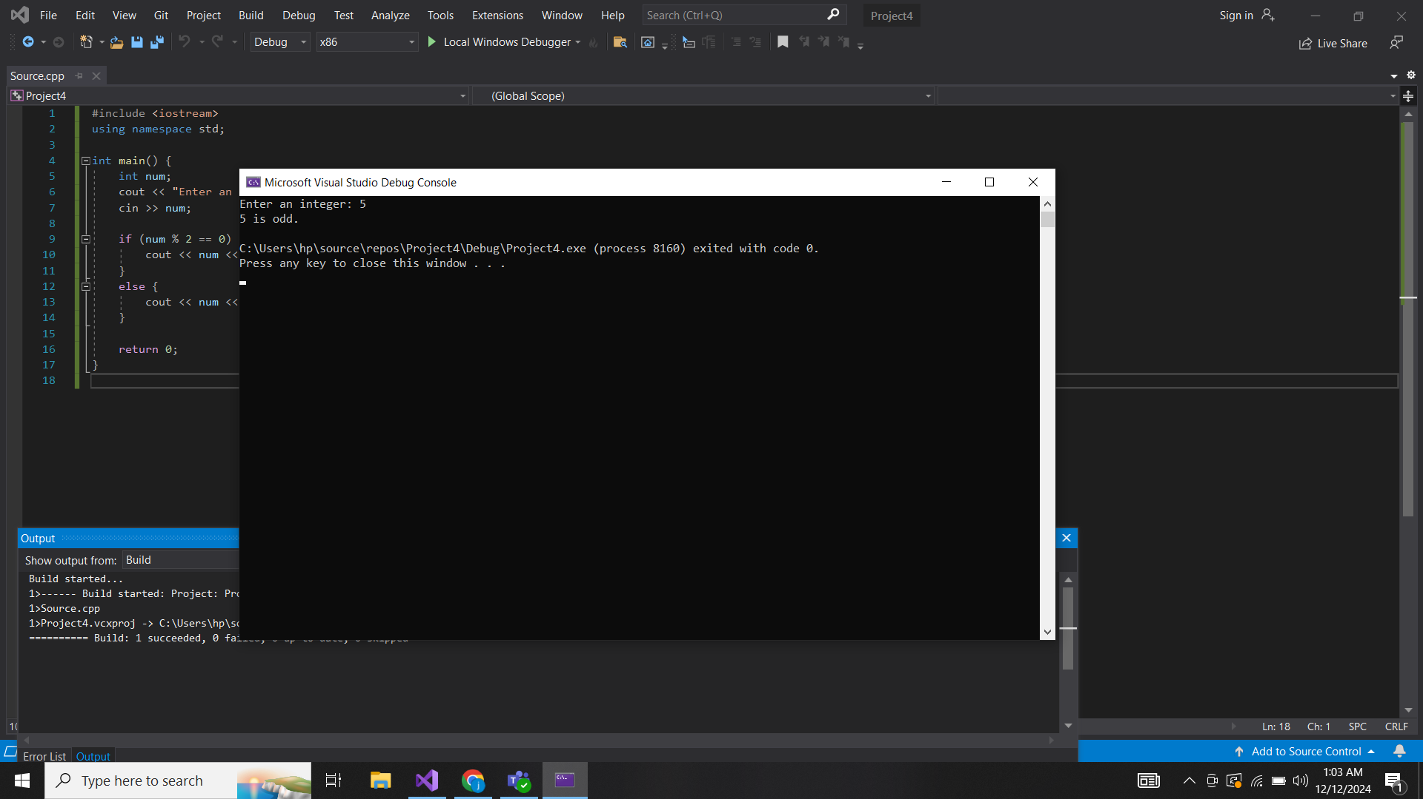

2.

#include <iostream>

using namespace std;

int main() {

int num1, num2, num3;

cout << "Enter three integers: ";

cin >> num1 >> num2 >> num3;

if (num1 >= num2 && num1 >= num3) {

cout << num1 << " is the largest number." << endl;

} else if (num2 >= num1 && num2 >= num3) {

cout << num2 << " is the largest number." << endl;

} else {

cout << num3 << " is the largest number." << endl;

}

return 0;

}

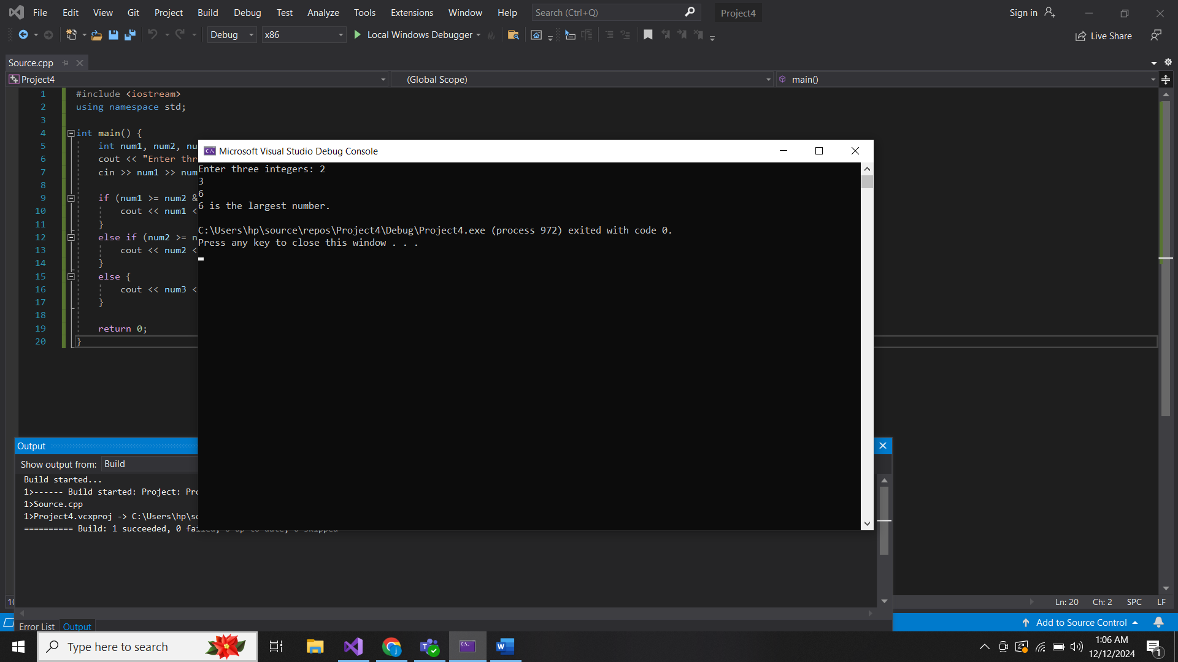

3.

#include <iostream>

using namespace std;

int main() {

int year;

cout << "Enter a year: ";

cin >> year;

if ((year % 4 == 0 && year % 100 != 0) || (year % 400 == 0)) {

cout << year << " is a leap year." << endl;

} else {

cout << year << " is not a leap year." << endl;

}

return 0;

}

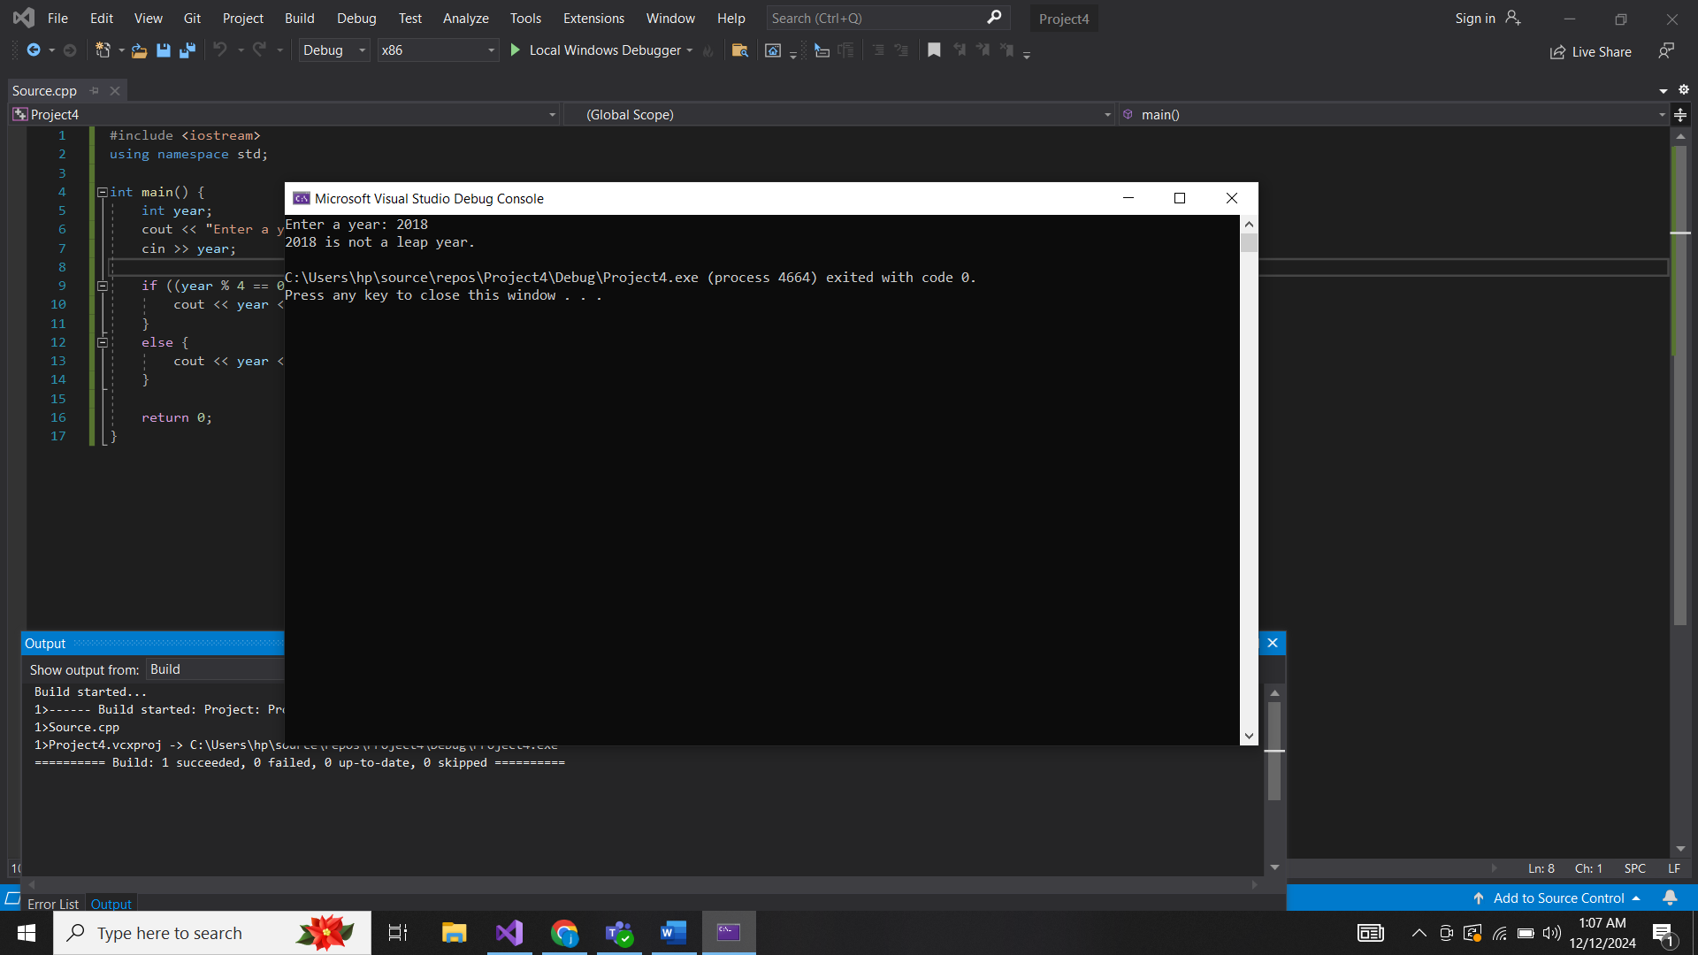

4.

#include <iostream>

using namespace std;

int main() {

int score;

cout << "Enter the student's score: ";

cin >> score;

if (score >= 90 && score <= 100) {

cout << "Grade: A" << endl;

}

else if (score >= 80 && score < 90) {

cout << "Grade: B" << endl;

}

else if (score >= 70 && score < 80) {

cout << "Grade: C" << endl;

}

else if (score >= 60 && score < 70) {

cout << "Grade: D" << endl;

}

else if (score < 60) {

cout << "Grade: F" << endl;

}

else {

cout << "Invalid score" << endl;

}

return 0;

}

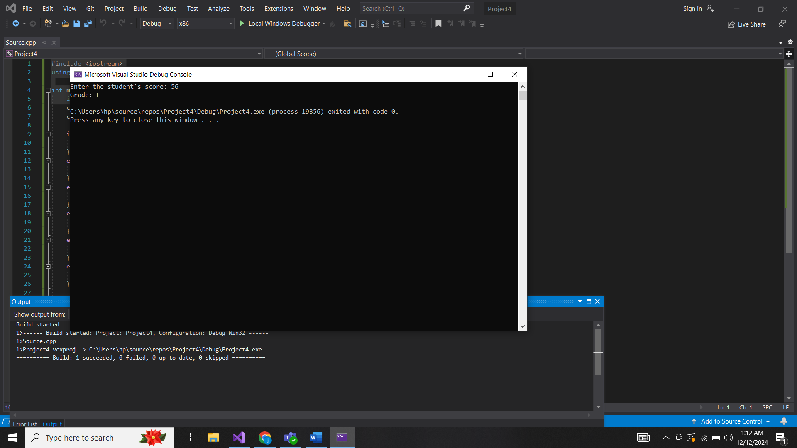

5.

#include <iostream>

using namespace std;

int main() {

char ch;

cout << "Enter a character: ";

cin >> ch;

if (ch == 'a' || ch == 'e' || ch == 'i' || ch == 'o' || ch == 'u' ||

ch == 'A' || ch == 'E' || ch == 'I' || ch == 'O' || ch == 'U') {

cout << ch << " is a vowel." << endl;

}

else {

cout << ch << " is a consonant." << endl;

}

return 0;

}

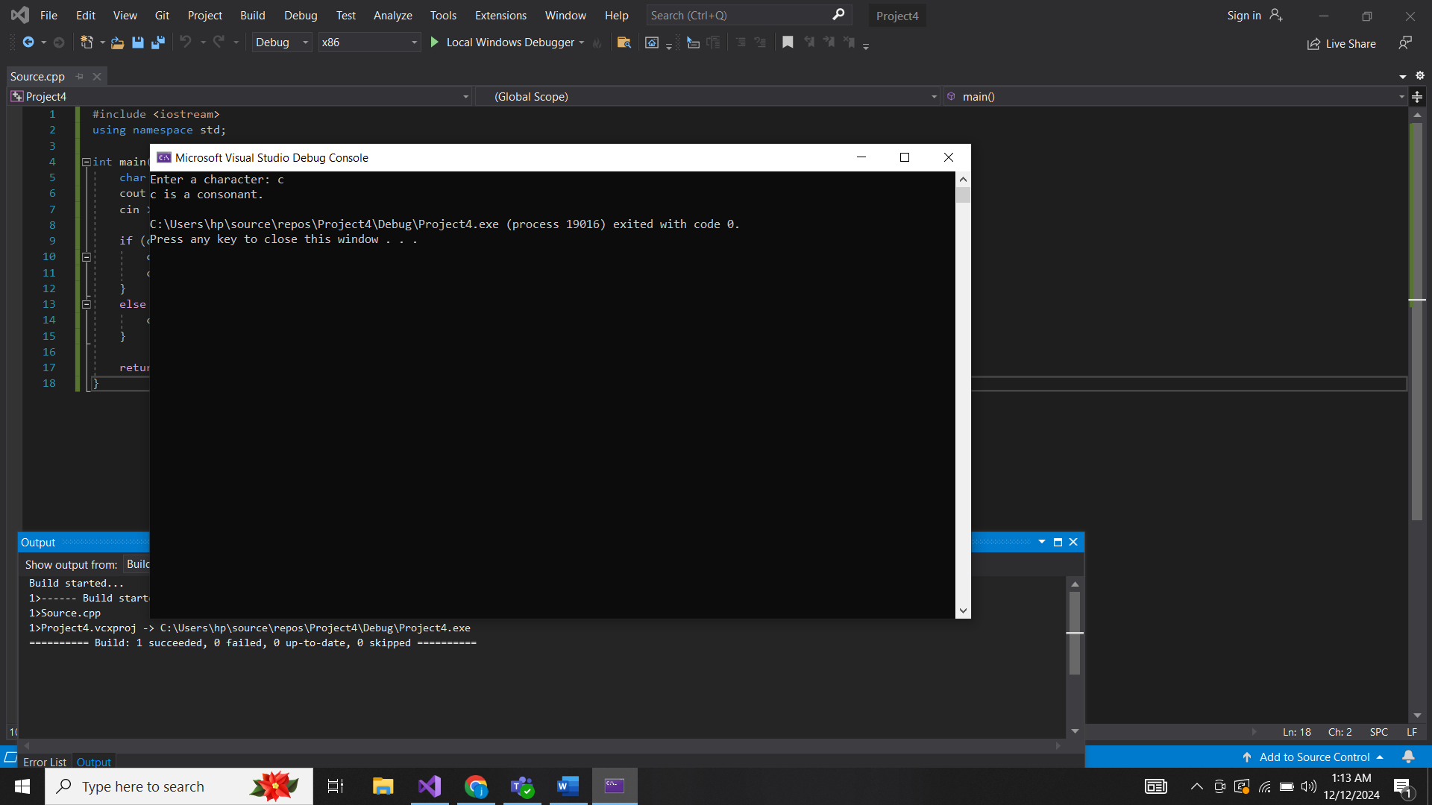

6.

#include <iostream>

using namespace std;

int main() {

int num;

cout << "Enter an integer: ";

cin >> num;

if (num > 0) {

cout << num << " is positive." << endl;

}

else if (num < 0) {

cout << num << " is negative." << endl;

}

else {

cout << "The number is zero." << endl;

}

return 0;

}

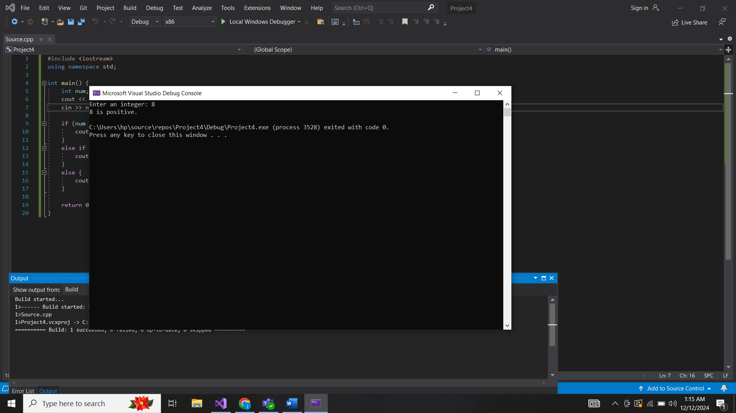

7.

#include <iostream>

using namespace std;

int main() {

int num;

cout << "Enter a number: ";

cin >> num;

bool isPrime = true;

if (num <= 1) {

isPrime = false;

}

else {

for (int i = 2; i <= num / 2; ++i) {

if (num % i == 0) {

isPrime = false;

break;

}

}

}

if (isPrime) {

cout << num << " is a prime number." << endl;

}

else {

cout << num << " is not a prime number." << endl;

}

return 0;

}

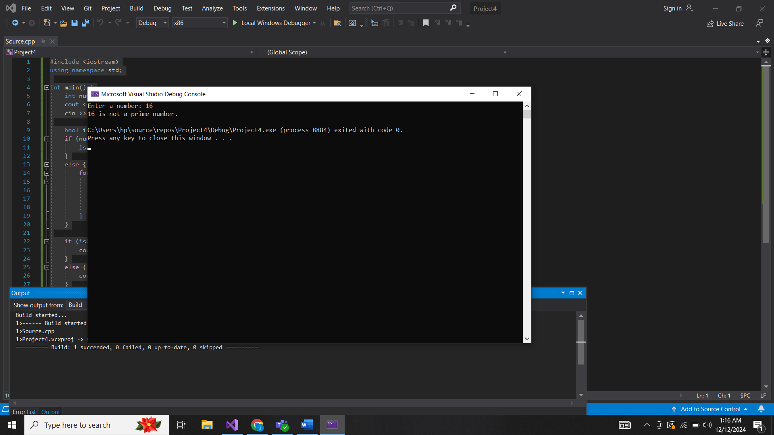

8.

#include <iostream>

using namespace std;

int main() {

double num1, num2;

char op;

cout << "Enter first number: ";

cin >> num1;

cout << "Enter an operator (+, -, *, /): ";

cin >> op;

cout << "Enter second number: ";

cin >> num2;

switch (op) {

case '+':

cout << "Result: " << num1 + num2 << endl;

break;

case '-':

cout << "Result: " << num1 - num2 << endl;

break;

case '*':

cout << "Result: " << num1 * num2 << endl;

break;

case '/':

if (num2 != 0) {

cout << "Result: " << num1 / num2 << endl;

}

else {

cout << "Error! Division by zero." << endl;

}

break;

default:

cout << "Invalid operator." << endl;

}

return 0;

}

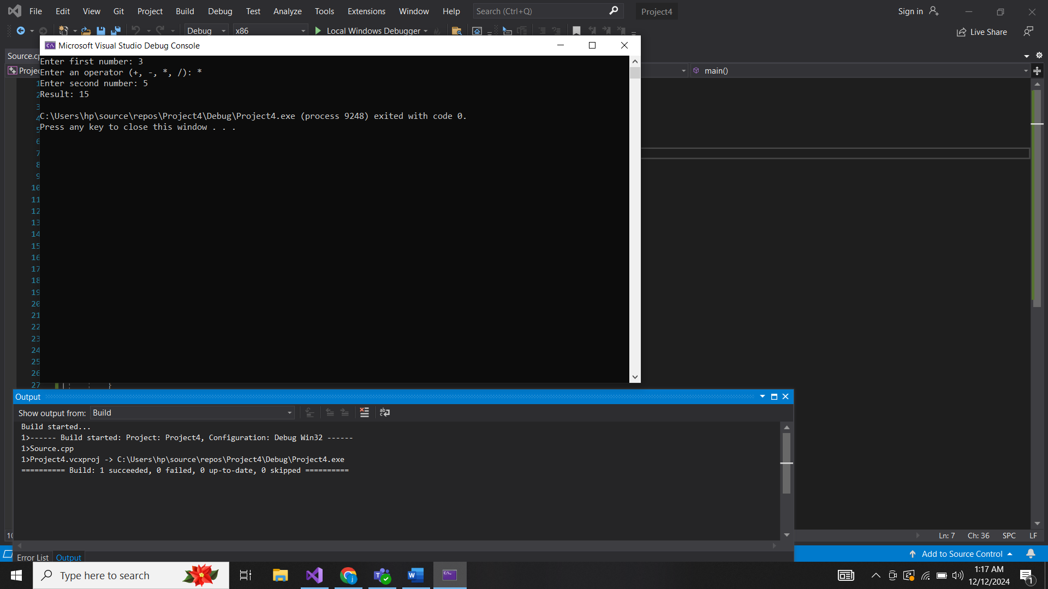

9.

#include <iostream>

using namespace std;

int main() {

int num;

cout << "Enter a number: ";

cin >> num;

if (num >= 0 && num <= 10) {

cout << "Range: 0-10" << endl;

} else if (num >= 11 && num <= 20) {

cout << "Range: 11-20" << endl;

} else if (num >= 21 && num <= 30) {

cout << "Range: 21-30" << endl;

} else if (num >= 31 && num <= 40) {

cout << "Range: 31-40" << endl;

} else if (num > 40) {

cout << "Range: Above 40" << endl;

} else {

cout << "Invalid input." << endl;

}

return 0;

}

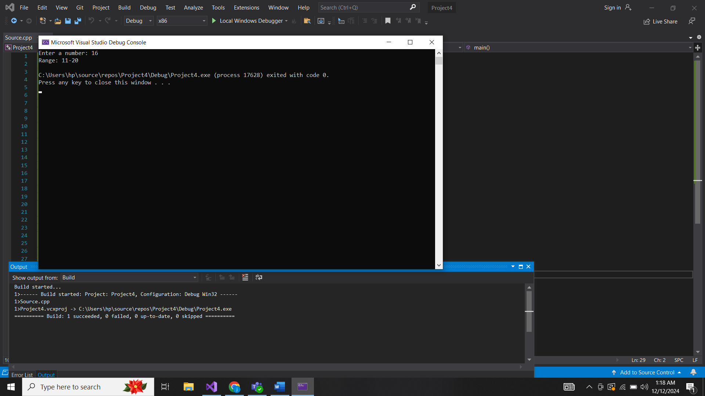

10.

#include <iostream>

using namespace std;

int main() {

int num;

cout << "Enter a number: ";

cin >> num;

bool allEven = true, allOdd = true;

while (num > 0) {

int digit = num % 10;

if (digit % 2 == 0) {

allOdd = false;

} else {

allEven = false;

}

num /= 10;

}

if (allEven) {

cout << "All digits are even." << endl;

} else if (allOdd) {

cout << "All digits are odd." << endl;

} else {

cout << "The number has a mix of even and odd digits." << endl;

}

return 0;

}

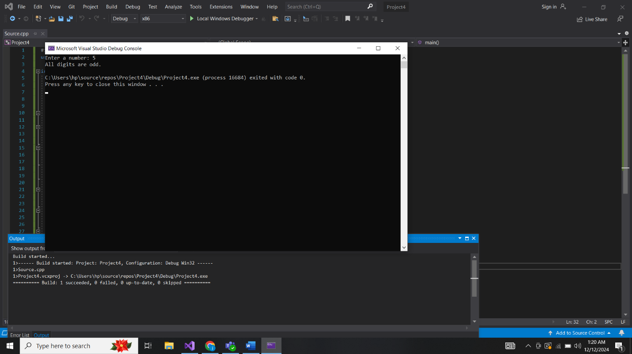

Loops:

1.

#include <iostream>

using namespace std;

int main() {

int n, sum = 0;

cout << "Enter a number: ";

cin >> n;

for (int i = 1; i <= n; i++) {

sum += i;

}

cout << "Sum of first " << n << " natural numbers is: " << sum << endl;

return 0;

}

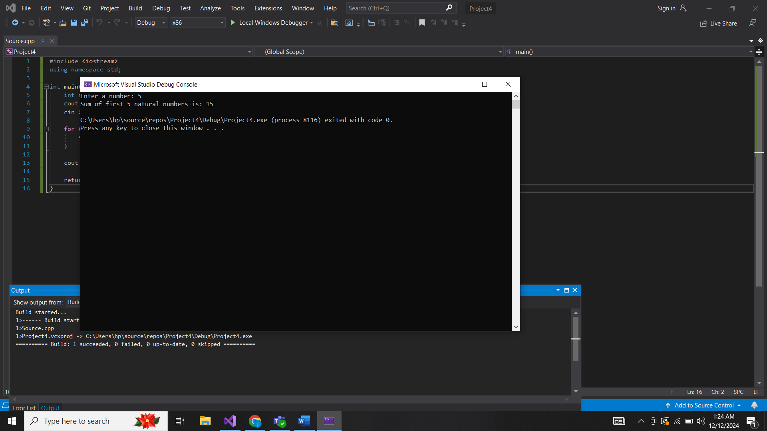

2.

#include <iostream>

using namespace std;

int main() {

int num, sum = 0;

cout << "Enter a number: ";

cin >> num;

for (int i = 1; i <= num / 2; ++i) {

if (num % i == 0) {

sum += i;

}

}

if (sum == num && num != 0) {

cout << num << " is a perfect number." << endl;

}

else {

bool isPrime = true;

if (num <= 1) {

isPrime = false;

}

else {

for (int i = 2; i <= num / 2; ++i) {

if (num % i == 0) {

isPrime = false;

break;

}

}

}

if (isPrime) {

cout << num << " is a prime number." << endl;

}

else {

cout << num << " is a composite number." << endl;

}

}

return 0;

}

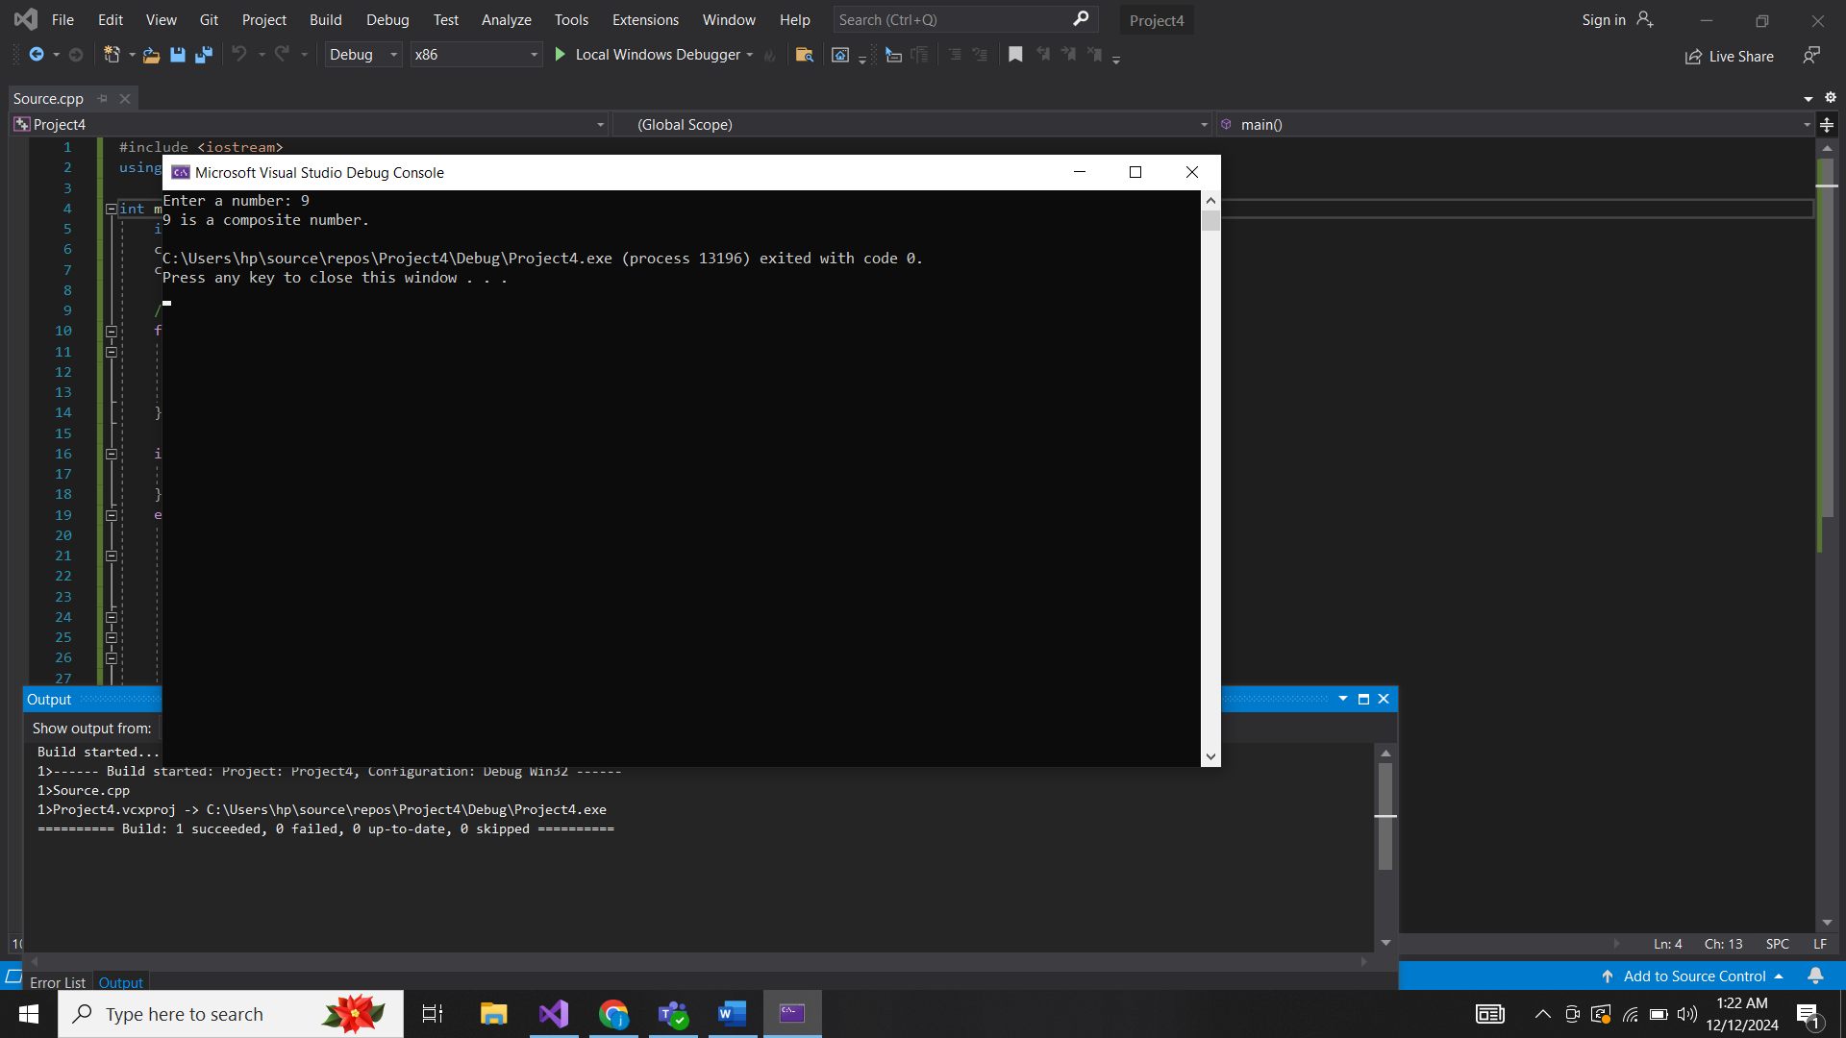

3.

#include <iostream>

using namespace std;

int main() {

int n, first = 0, second = 1, next;

cout << "Enter the number of terms: ";

cin >> n;

cout << "Fibonacci Series: ";

for (int i = 1; i <= n; ++i) {

cout << first << " ";

next = first + second;

first = second;

second = next;

}

cout << endl;

return 0;

}

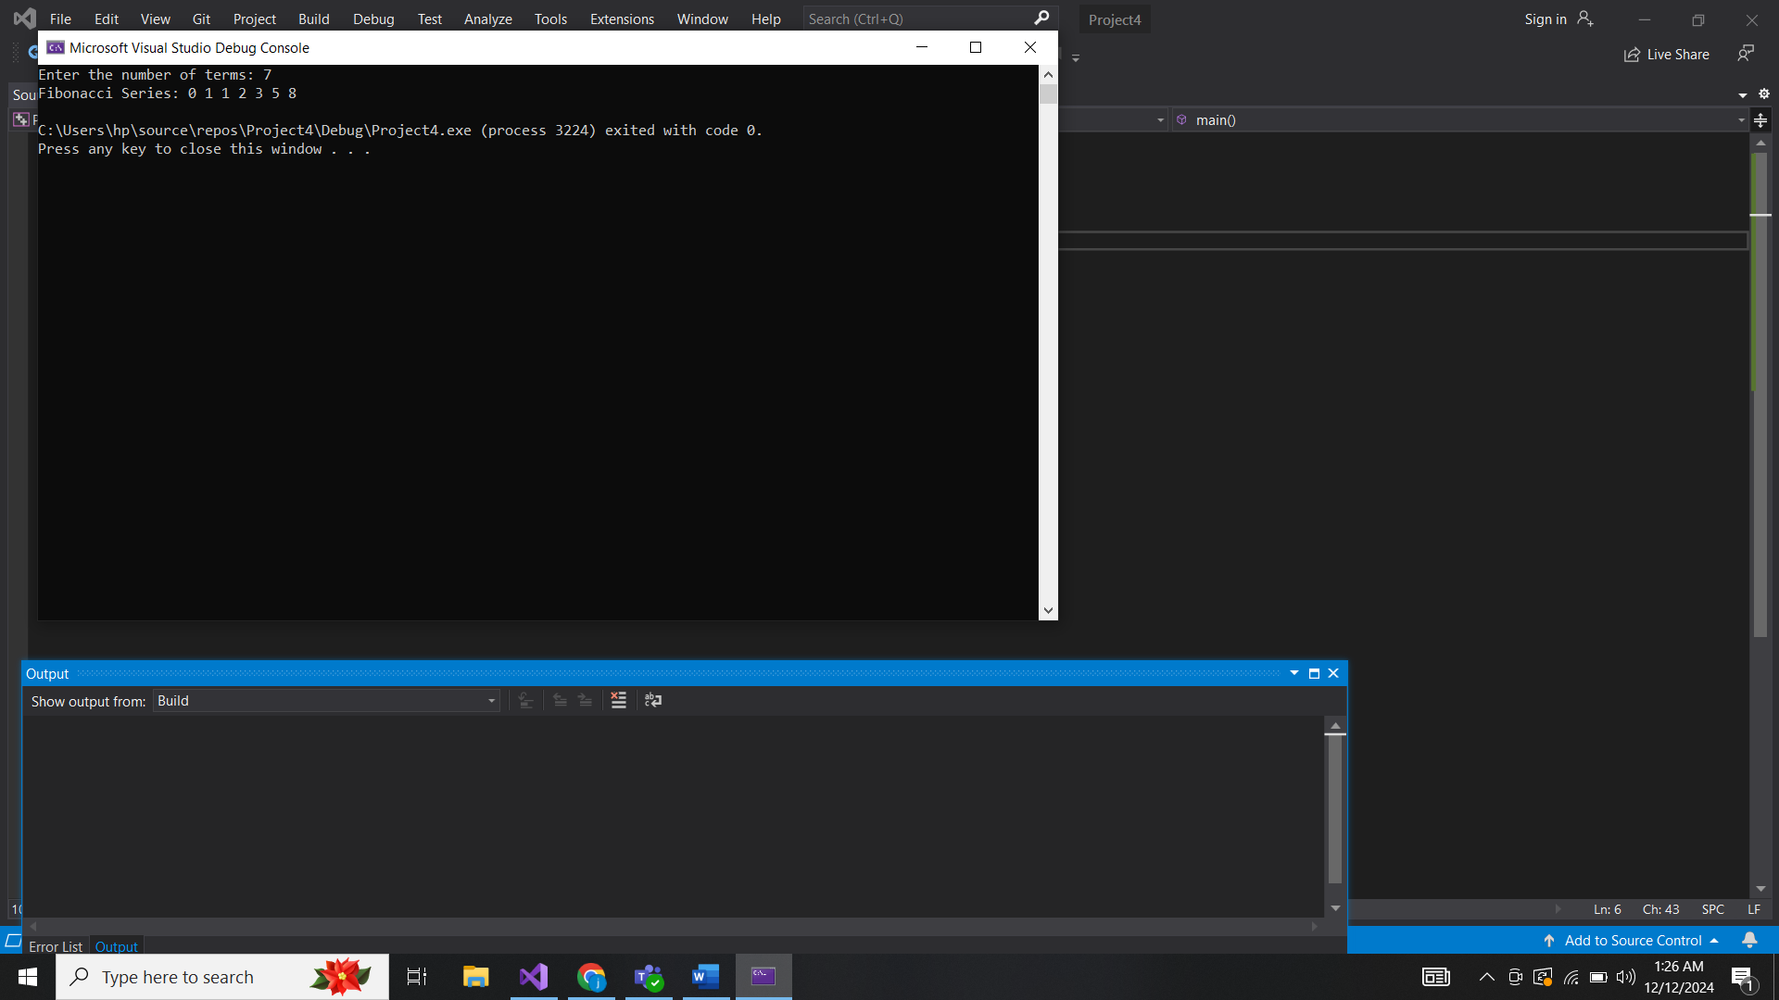

4.

#include <iostream>

using namespace std;

int main() {

int n;

long long factorial = 1;

cout << "Enter a number: ";

cin >> n;

for (int i = 1; i <= n; i++) {

factorial *= i;

}

cout << "Factorial of " << n << " is: " << factorial << endl;

return 0;

}

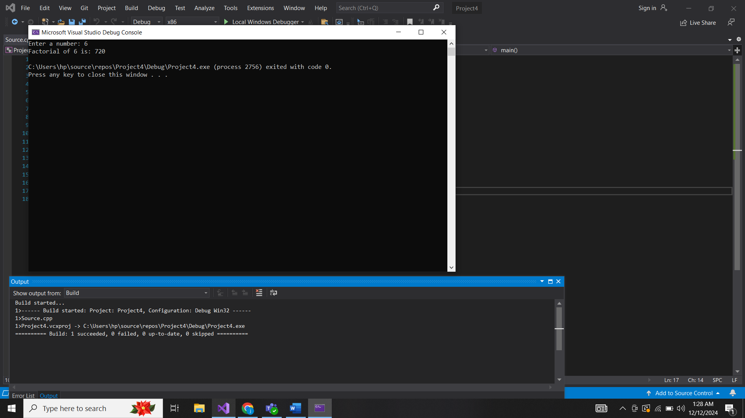

5.

#include <iostream>

using namespace std;

int main() {

int n;

cout << "Enter a number: ";

cin >> n;

cout << "Prime numbers between 1 and " << n << " are: ";

for (int i = 2; i <= n; i++) {

bool prime = true;

for (int j = 2; j <= i / 2; j++) {

if (i % j == 0) {

prime = false;

break;

}

}

if (prime) {

cout << i << " ";

}

}

cout << endl;

return 0;

}

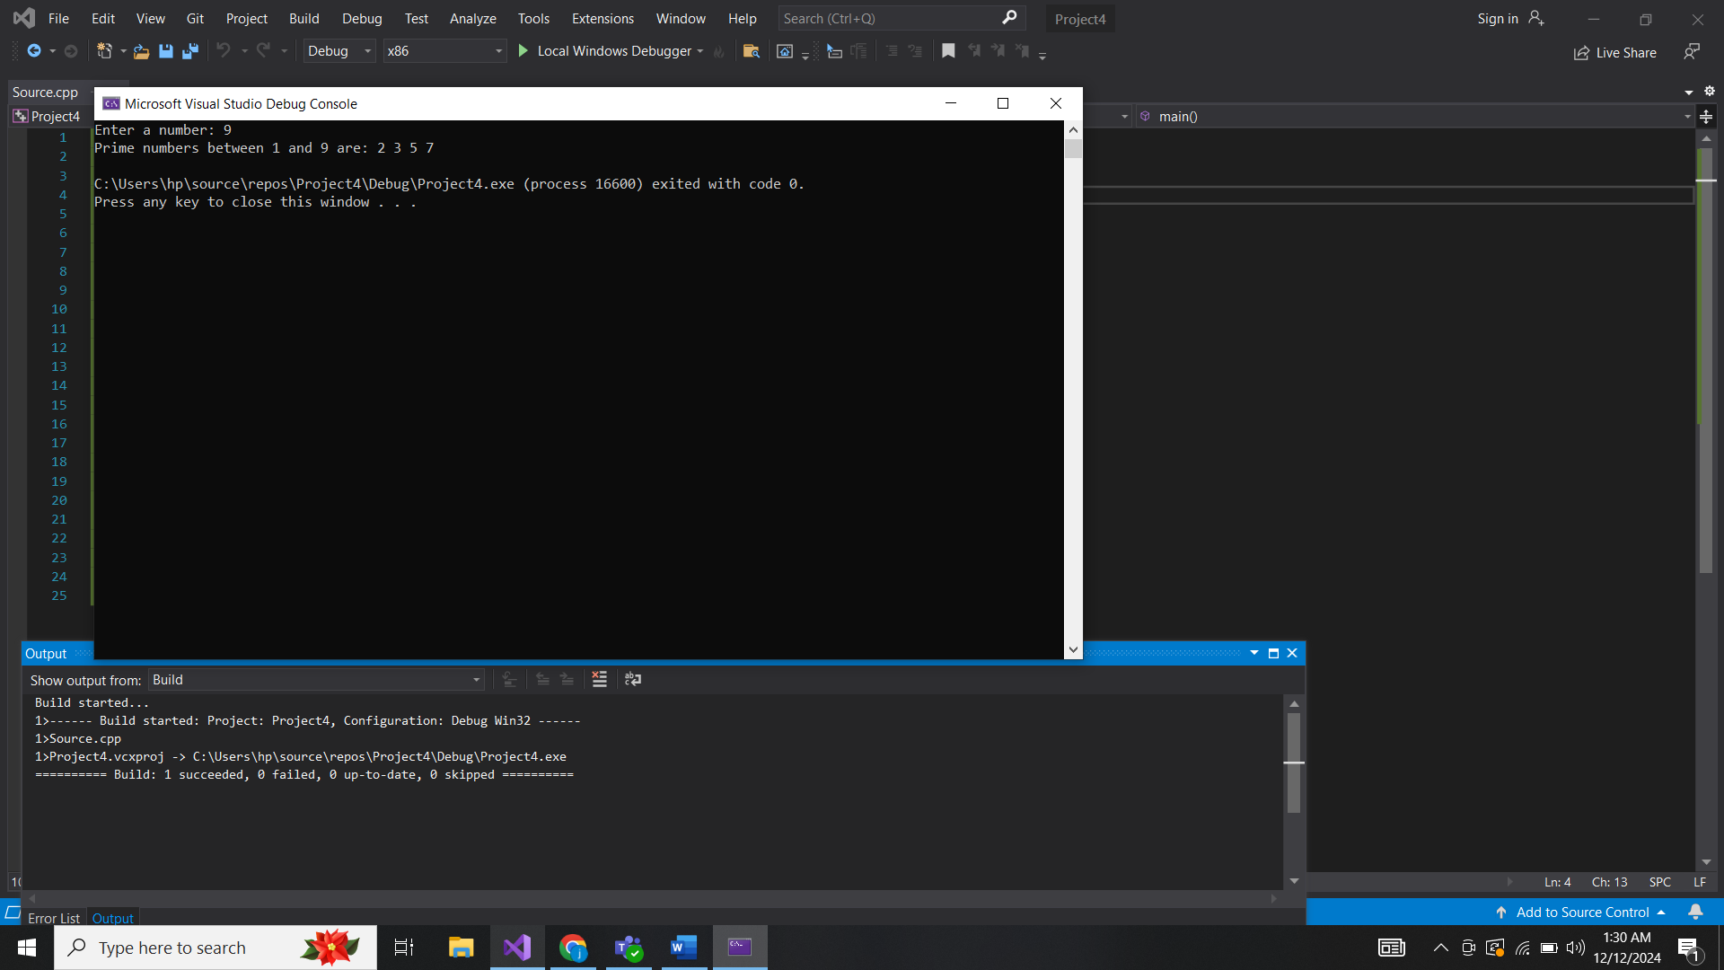

6.

#include <iostream>

using namespace std;

int main() {

int n, reversed = 0;

cout << "Enter a number: ";

cin >> n;

while (n != 0) {

reversed = reversed * 10 + n % 10;

n /= 10;

}

cout << "Reversed number is: " << reversed << endl;

return 0;

}

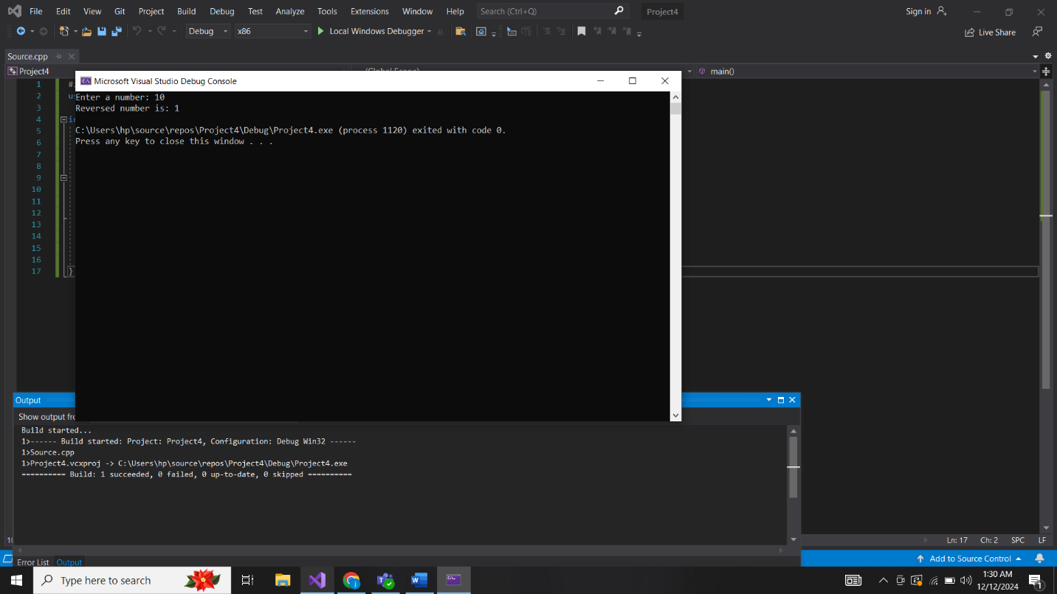

7.

#include <iostream>

using namespace std;

int main() {

int n, sum = 0;

cout << "Enter a number: ";

cin >> n;

while (n != 0) {

sum += n % 10;

n /= 10;

}

cout << "Sum of digits is: " << sum << endl;

return 0;

}

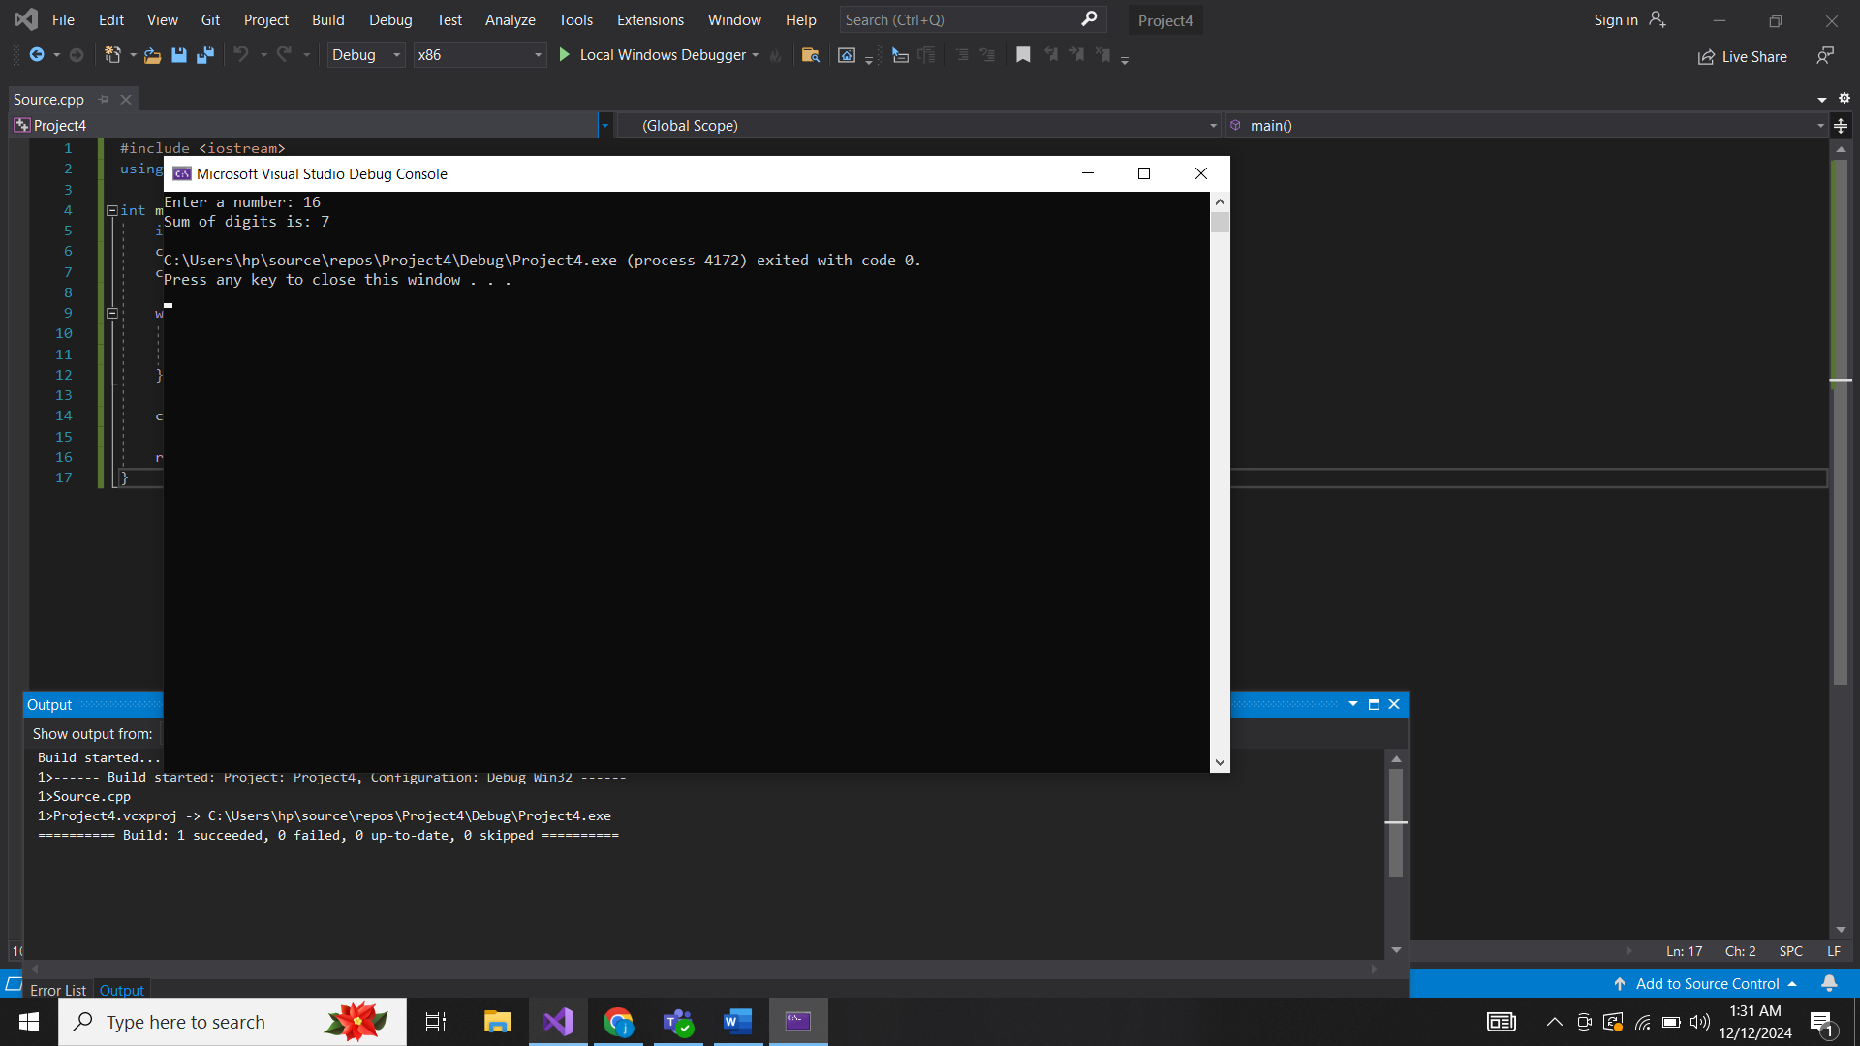

8.

#include <iostream>

using namespace std;

int main() {

int n;

cout << "Enter number of rows: ";

cin >> n;

for (int i = 1; i <= n; i++) {

for (int j = 1; j <= i; j++) {

cout << "*";

}

cout << endl;

}

return 0;

}

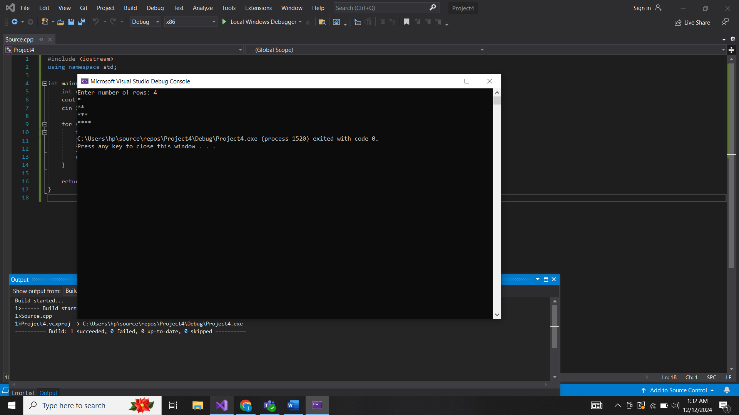

9.

#include <iostream>

using namespace std;

int main() {

int n;

cout << "Enter the size of the square: ";

cin >> n;

for (int i = 1; i <= n; i++) {

for (int j = 1; j <= n; j++) {

cout << "*";

}

cout << endl;

}

return 0;

}

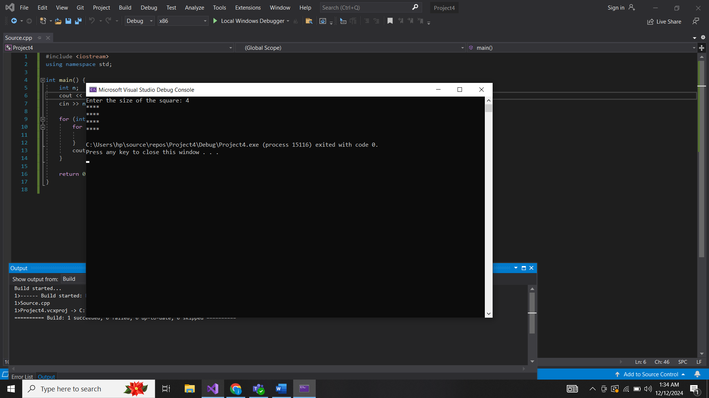

10.

#include <iostream>

using namespace std;

int main() {

int a, b;

cout << "Enter two numbers: ";

cin >> a >> b;

int gcd = 1;

for (int i = 1; i <= a && i <= b; i++) {

if (a % i == 0 && b % i == 0) {

gcd = i;

}

}

cout << "GCD of " << a << " and " << b << " is: " << gcd << endl;

return 0;

}

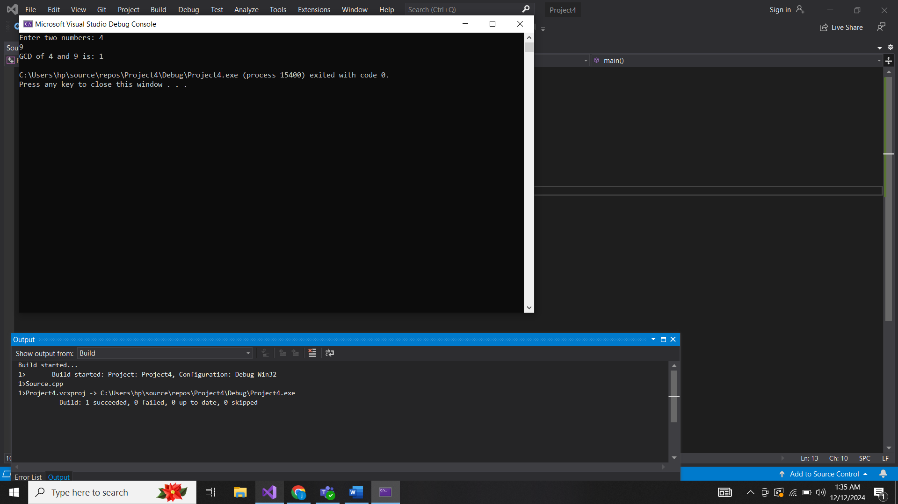

Functions:

1.

#include <iostream>

using namespace std;

int sum(int a, int b) {

return a + b;

}

int main() {

int x, y;

cout << "Enter two numbers: ";

cin >> x >> y;

cout << "Sum of " << x << " and " << y << " is: " << sum(x, y) << endl;

return 0;

}

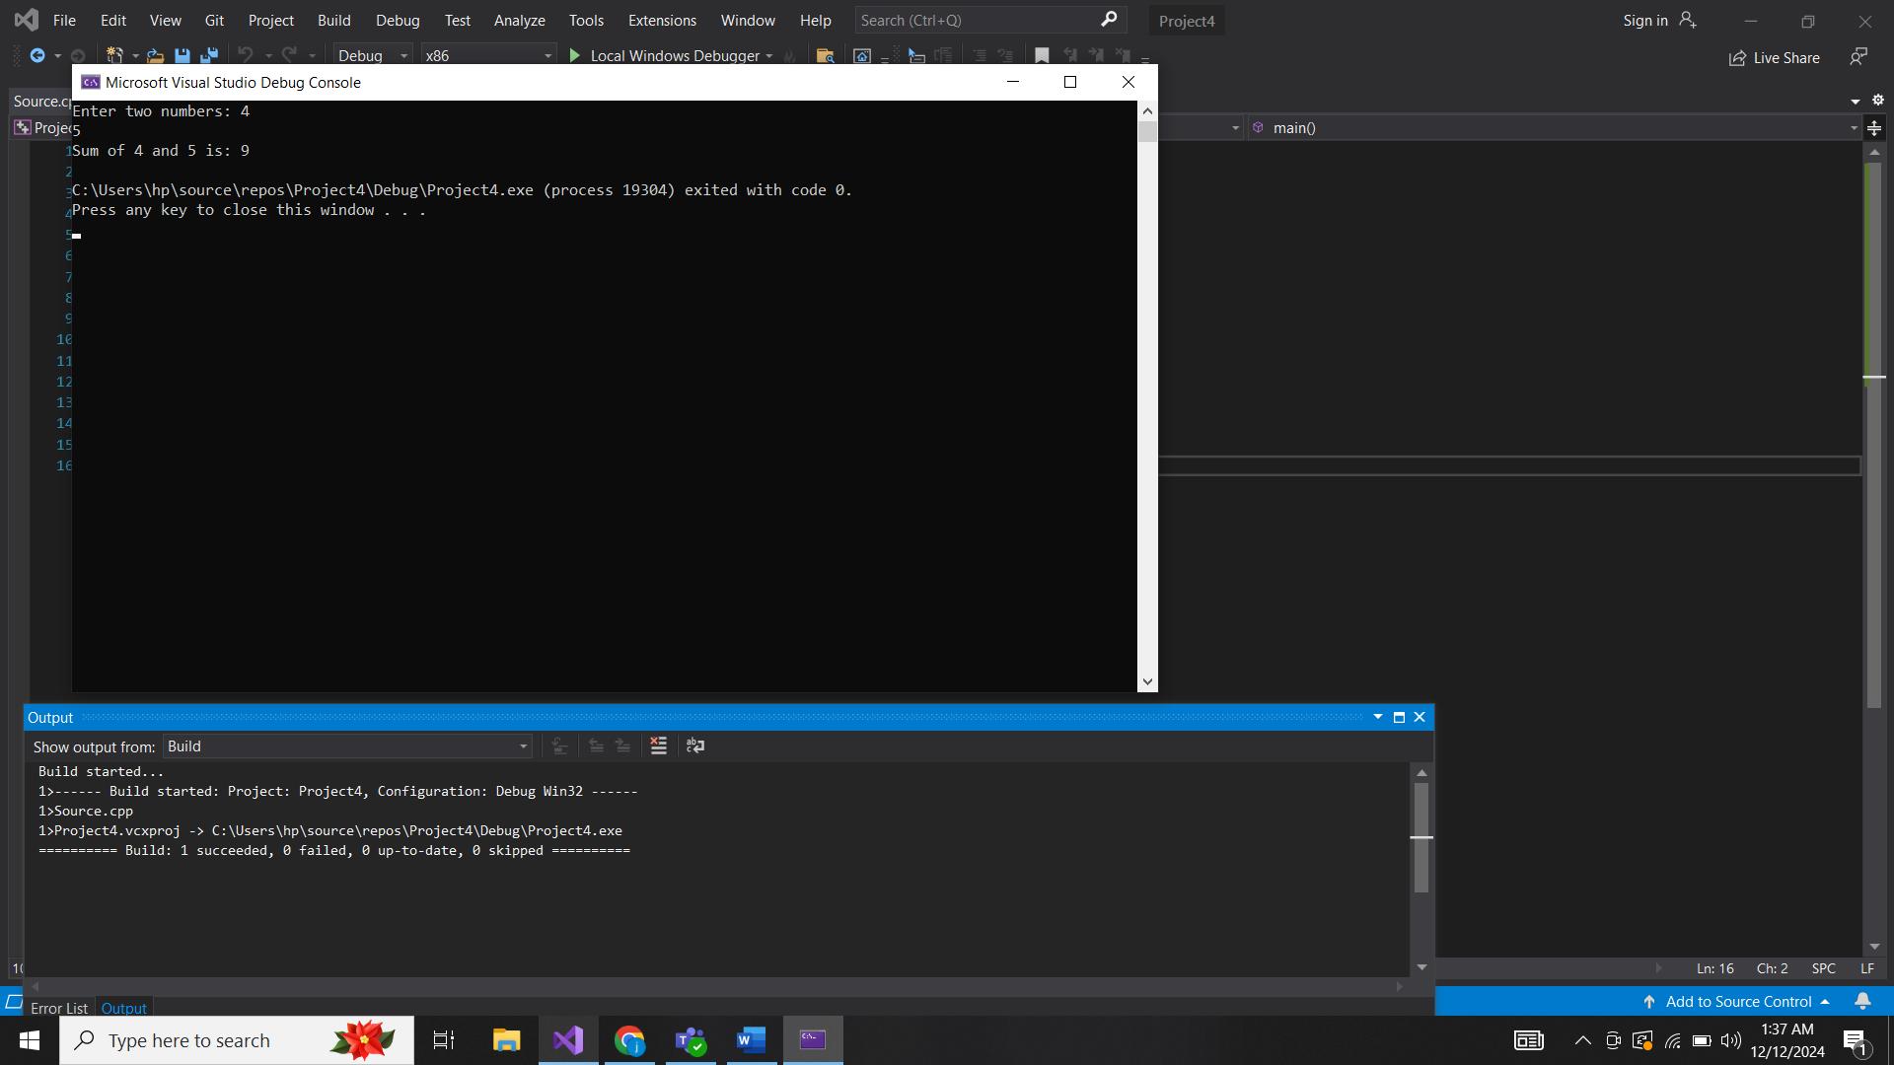

2.

#include <iostream>

using namespace std;

long long factorial(int n) {

long long fact = 1;

for (int i = 1; i <= n; i++) {

fact *= i;

}

return fact;

}

int main() {

int num;

cout << "Enter a number: ";

cin >> num;

cout << "Factorial of " << num << " is: " << factorial(num) << endl;

return 0;

}

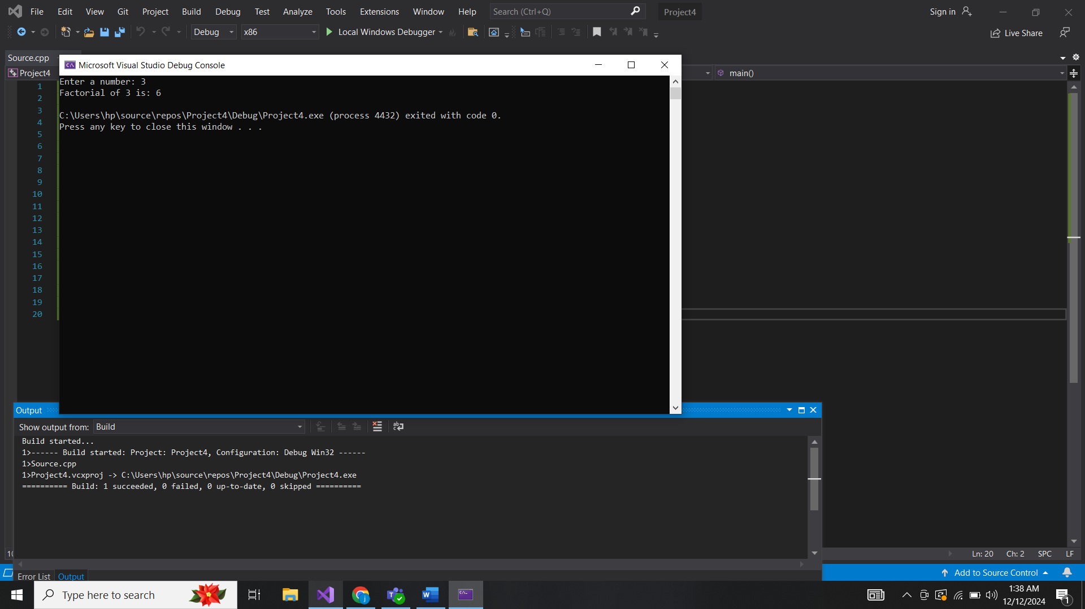

3.

#include <iostream>

using namespace std;

bool isPrime(int n) {

if (n <= 1) return false;

for (int i = 2; i <= n / 2; i++) {

if (n % i == 0) return false;

}

return true;

}

int main() {

int num;

cout << "Enter a number: ";

cin >> num;

if (isPrime(num)) {

cout << num << " is a prime number." << endl;

}

else {

cout << num << " is not a prime number." << endl;

}

return 0;

}

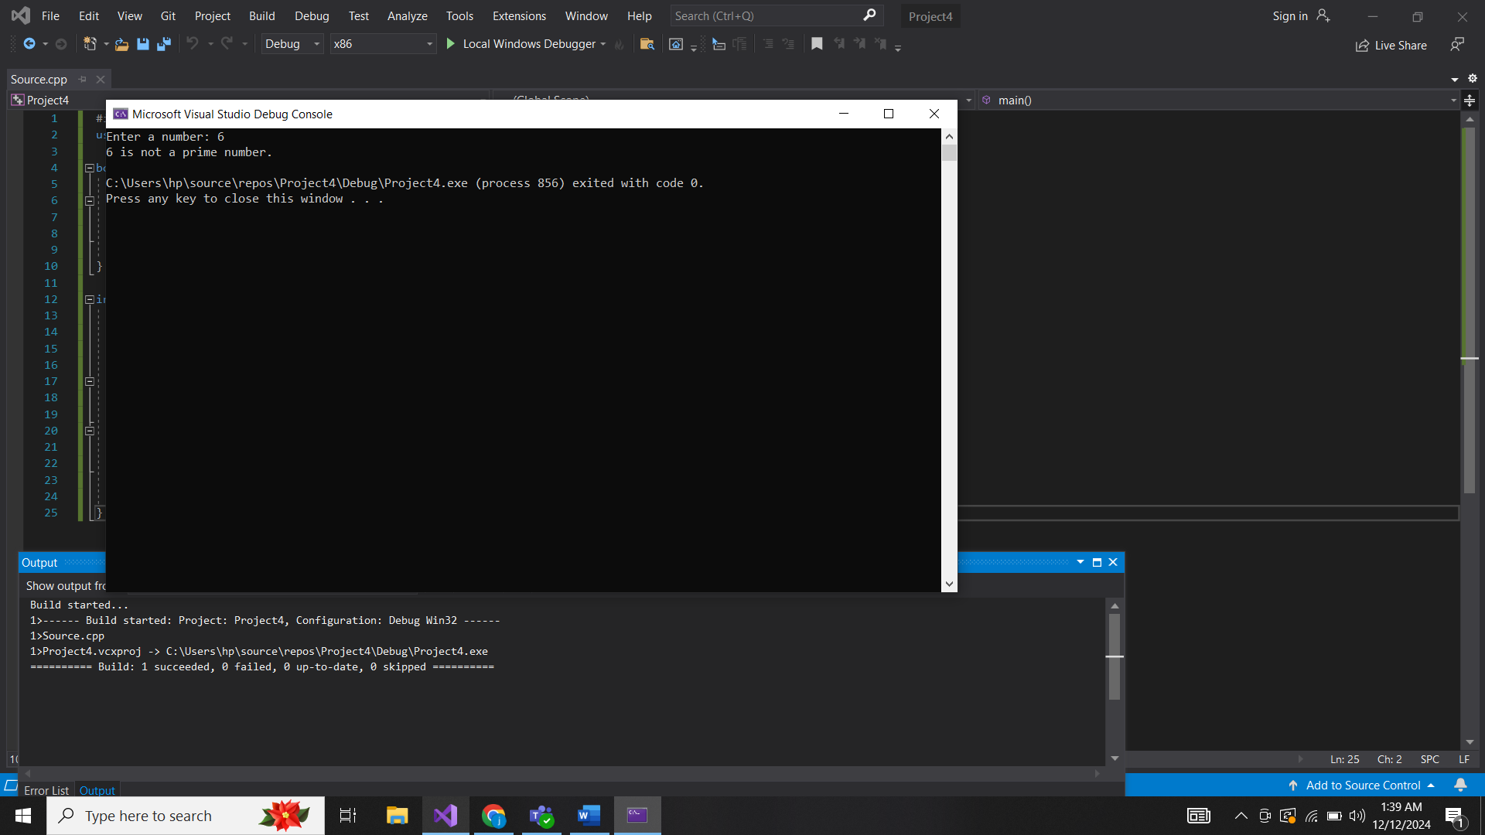

4.

#include <iostream>

using namespace std;

int max(int a, int b) {

return (a > b) ? a : b;

}

int main() {

int x, y;

cout << "Enter two numbers: ";

cin >> x >> y;

cout << "The maximum of " << x << " and " << y << " is: " << max(x, y) << endl;

return 0;

}

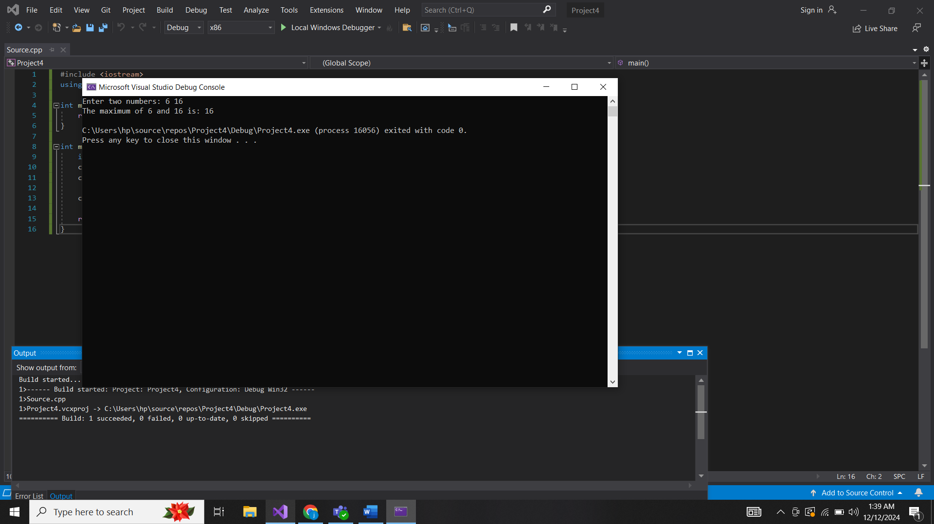

5.

#include <iostream>

#include <cmath>

using namespace std;

double power(double base, int exponent) {

return pow(base, exponent);

}

int main() {

double base;

int exponent;

cout << "Enter base and exponent: ";

cin >> base >> exponent;

cout << base << " raised to the power of " << exponent << " is: " << power(base, exponent) << endl;

return 0;

}

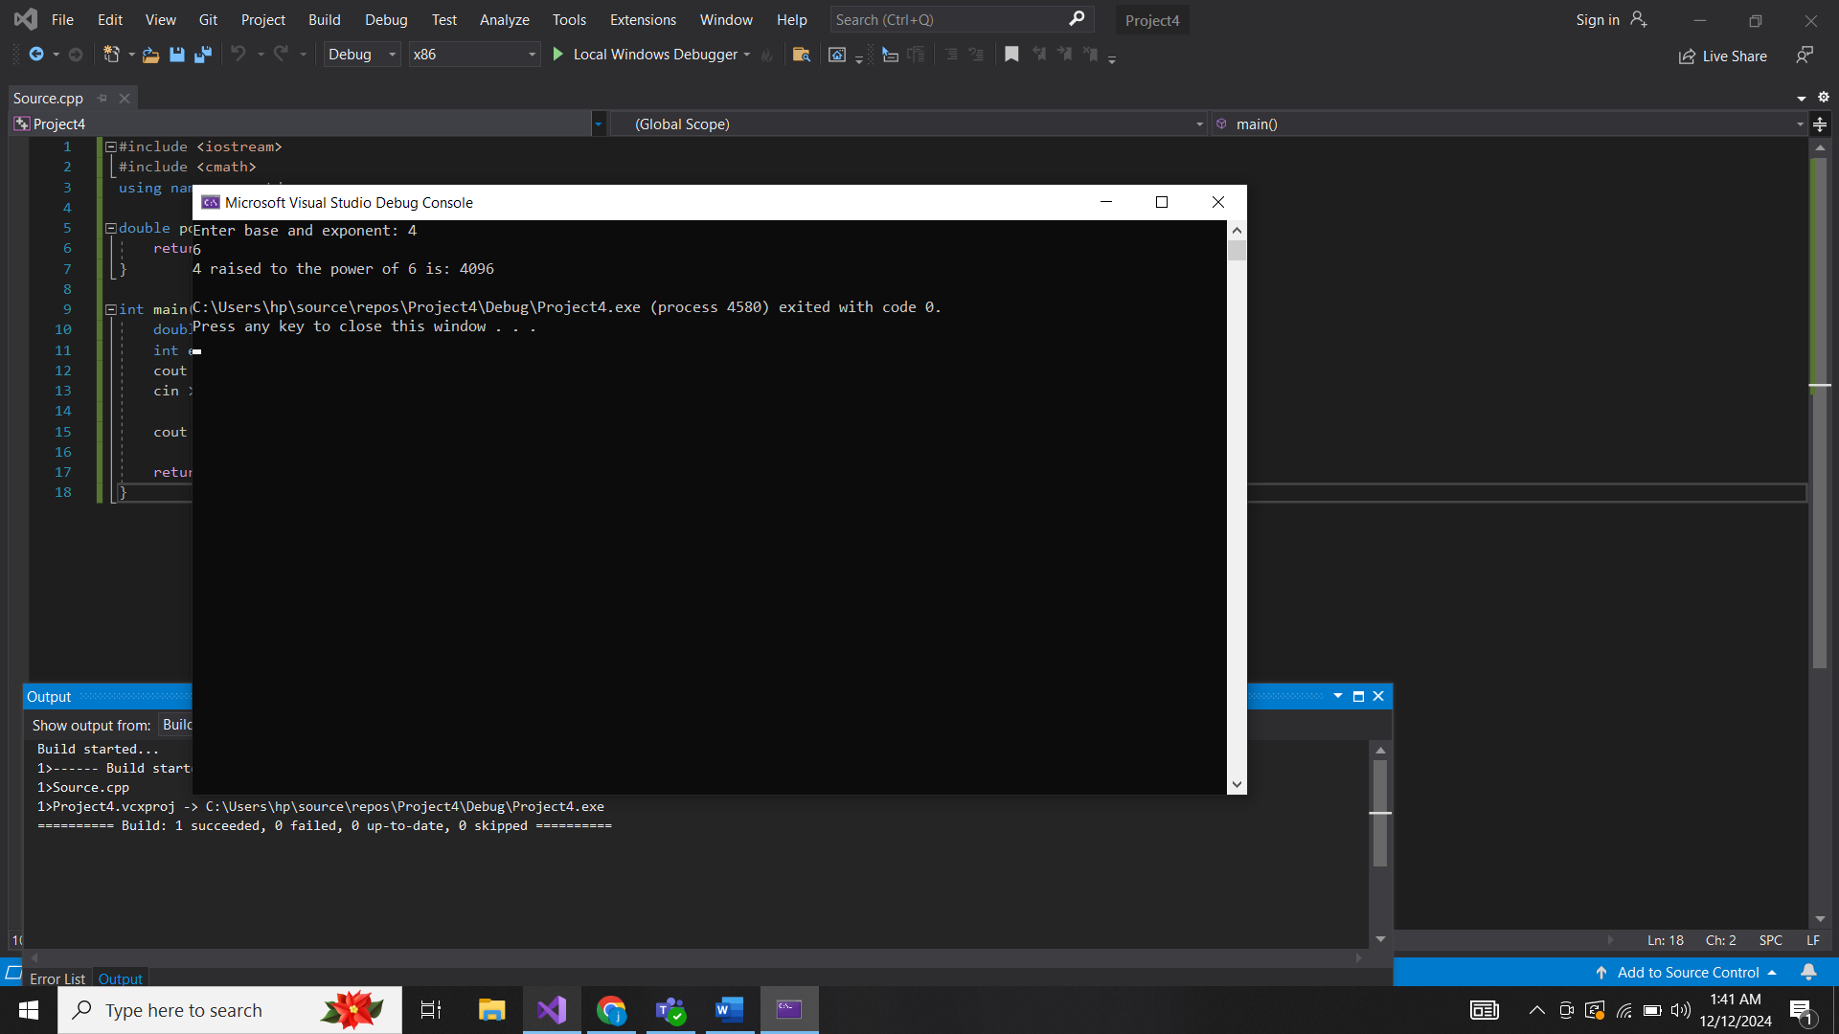

6.

#include <iostream>

using namespace std;

void fibonacci(int n) {

int first = 0, second = 1, next;

for (int i = 1; i <= n; i++) {

cout << first << " ";

next = first + second;

first = second;

second = next;

}

cout << endl;

}

int main() {

int n;

cout << "Enter the number of terms: ";

cin >> n;

cout << "Fibonacci series: ";

fibonacci(n);

return 0;

}

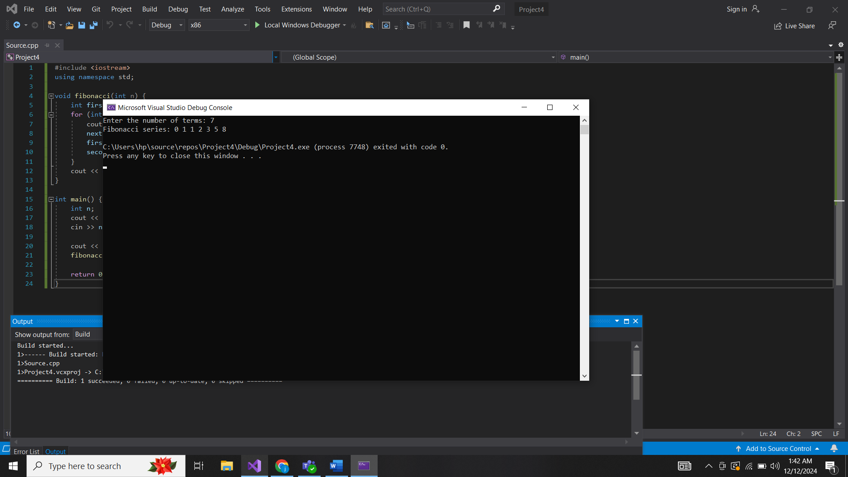

7.

#include <iostream>

using namespace std;

void swapNumbers(int& a, int& b) {

int temp = a;

a = b;

b = temp;

}

int main() {

int x, y;

cout << "Enter two numbers: ";

cin >> x >> y;

swapNumbers(x, y);

cout << "After swapping, first number is: " << x << " and second number is: " << y << endl;

return 0;

}

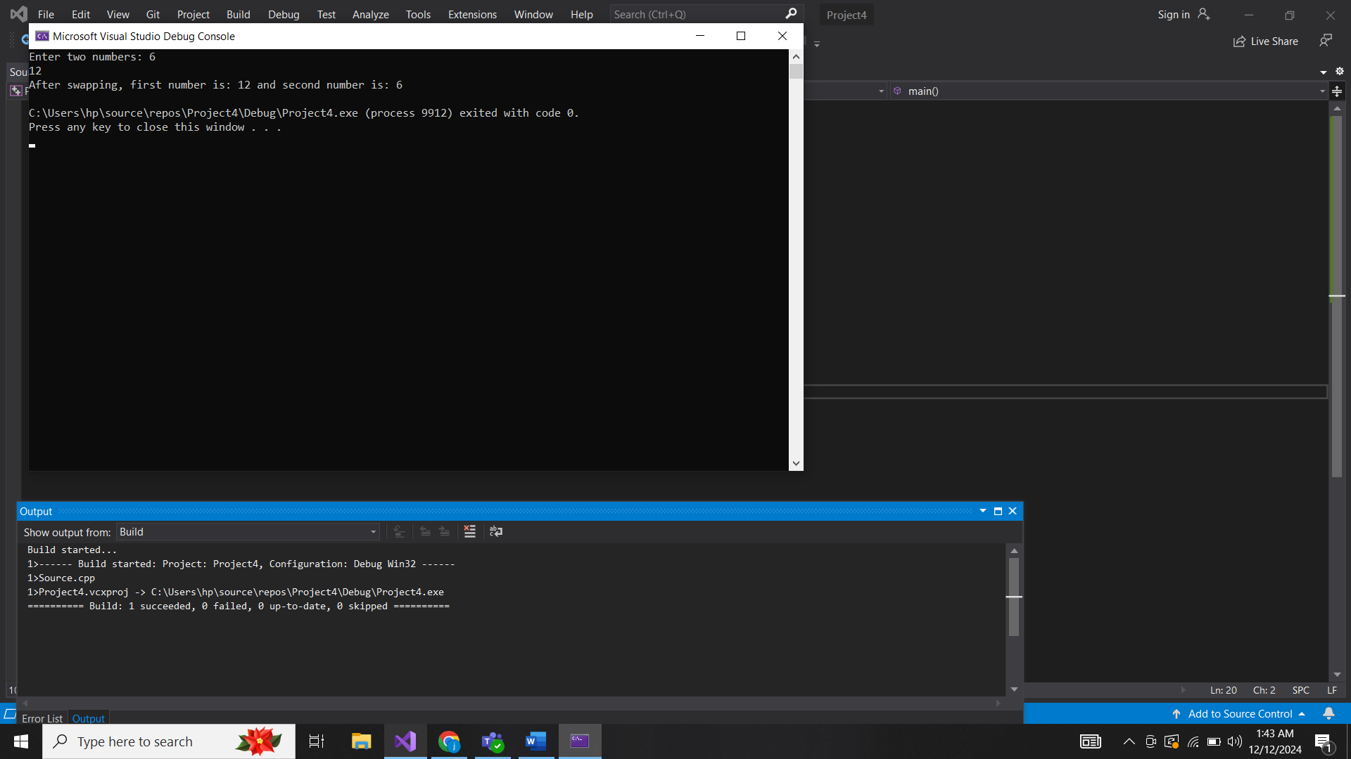

8.

#include <iostream>

using namespace std;

int gcd(int a, int b) {

while (b != 0) {

int temp = b;

b = a % b;

a = temp;

}

return a;

}

int main() {

int x, y;

cout << "Enter two numbers: ";

cin >> x >> y;

cout << "GCD of " << x << " and " << y << " is: " << gcd(x, y) << endl;

return 0;

}

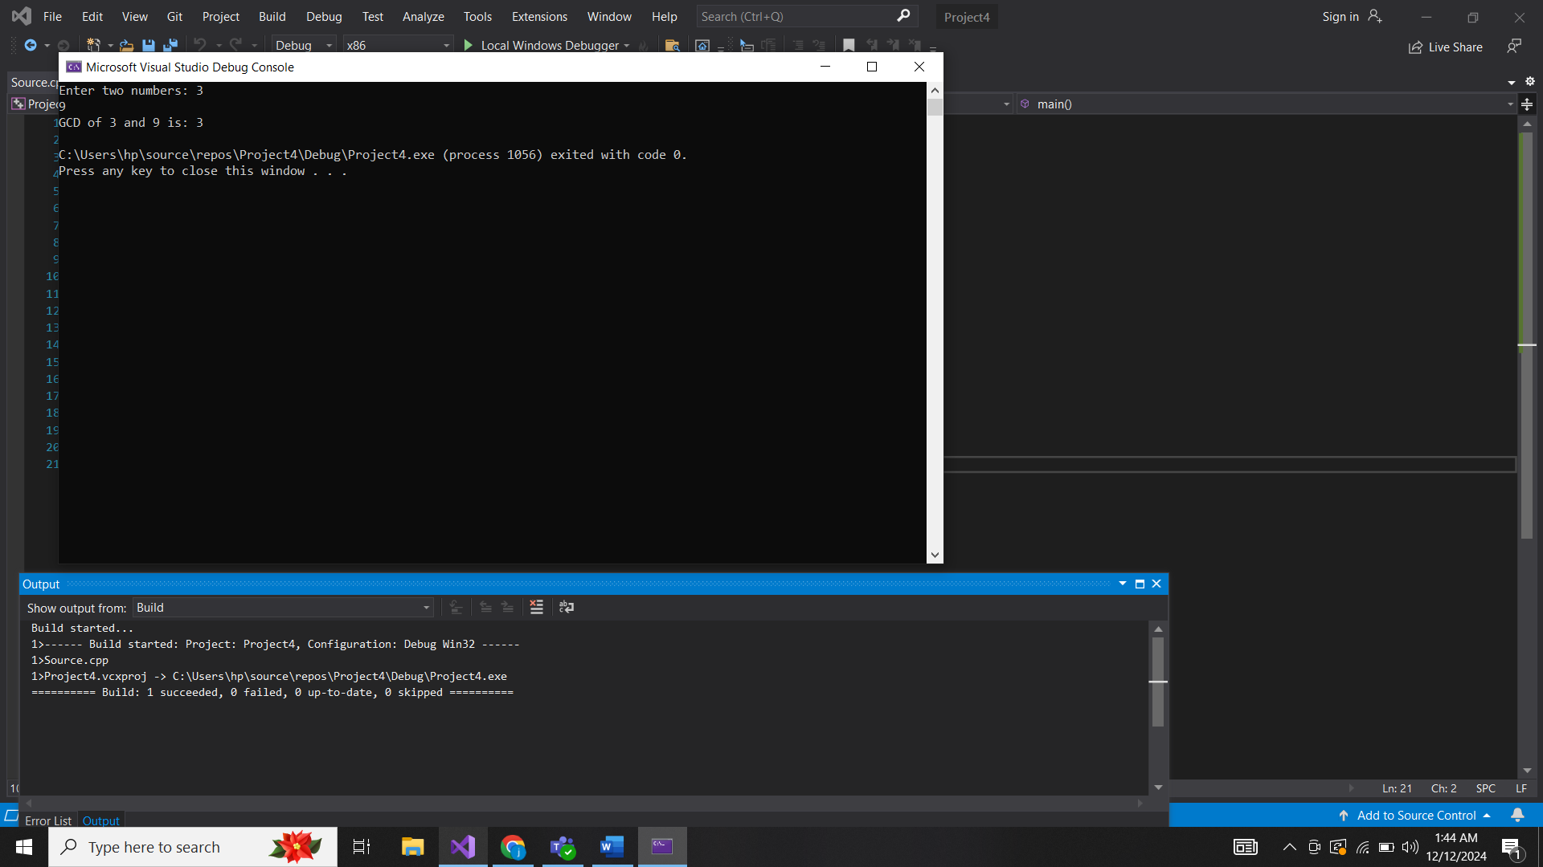

9.

#include <iostream>

using namespace std;

bool isPrime(int n) {

if (n <= 1) return false;

for (int i = 2; i <= n / 2; i++) {

if (n % i == 0) return false;

}

return true;

}

void printPrimesInRange(int start, int end) {

for (int i = start; i <= end; i++) {

if (isPrime(i)) {

cout << i << " ";

}

}

cout << endl;

}

int main() {

int start, end;

cout << "Enter the range (start and end): ";

cin >> start >> end;

cout << "Prime numbers between " << start << " and " << end << " are: ";

printPrimesInRange(start, end);

return 0;

}

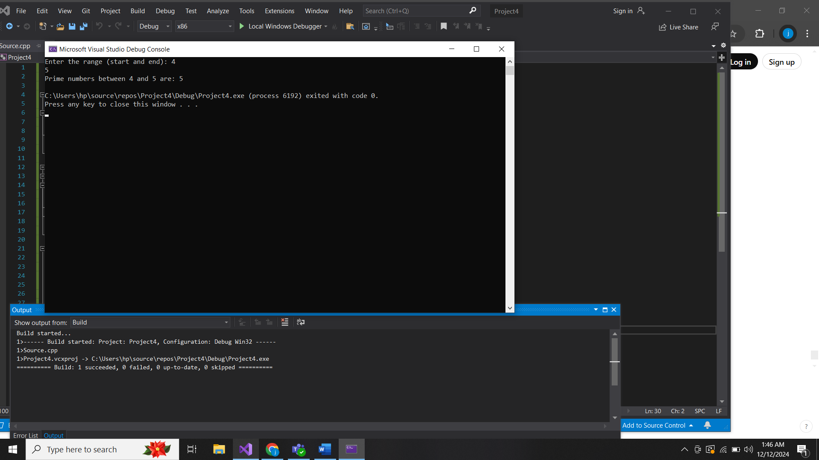

Arrays:

1.

#include <iostream>

using namespace std;

int largestElement(int arr[], int size) {

int largest = arr[0];

for (int i = 1; i < size; i++) {

if (arr[i] > largest) {

largest = arr[i];

}

}

return largest;

}

int main() {

int arr[] = { 12, 34, 56, 1, 89 };

int size = sizeof(arr) / sizeof(arr[0]);

cout << "Largest element: " << largestElement(arr, size) << endl;

return 0;

}

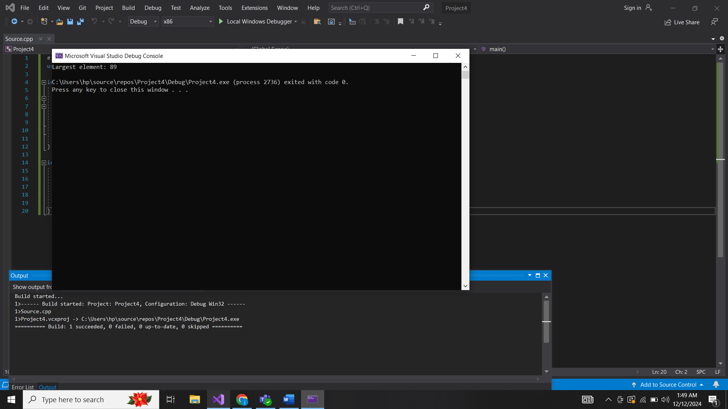

2.

#include <iostream>

using namespace std;

int smallestElement(int arr[], int size) {

int smallest = arr[0];

for (int i = 1; i < size; i++) {

if (arr[i] < smallest) {

smallest = arr[i];

}

}

return smallest;

}

int main() {

int arr[] = { 12, 34, 56, 1, 89 };

int size = sizeof(arr) / sizeof(arr[0]);

cout << "Smallest element: " << smallestElement(arr, size) << endl;

return 0;

}

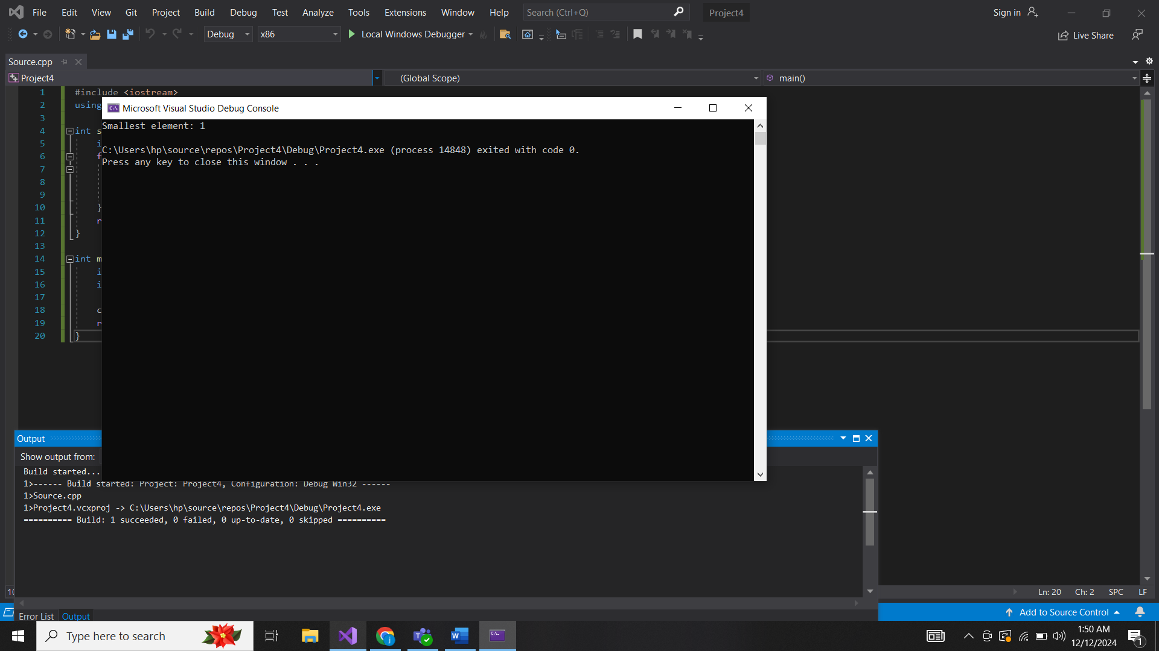

3.

#include <iostream>

using namespace std;

void reverseArray(int arr[], int size) {

int start = 0, end = size - 1;

while (start < end) {

swap(arr[start], arr[end]);

start++;

end--;

}

}

void displayArray(int arr[], int size) {

for (int i = 0; i < size; i++) {

cout << arr[i] << " ";

}

cout << endl;

}

int main() {

int arr[] = { 1, 2, 3, 4, 5 };

int size = sizeof(arr) / sizeof(arr[0]);

cout << "Original array: ";

displayArray(arr, size);

reverseArray(arr, size);

cout << "Reversed array: ";

displayArray(arr, size);

return 0;

}

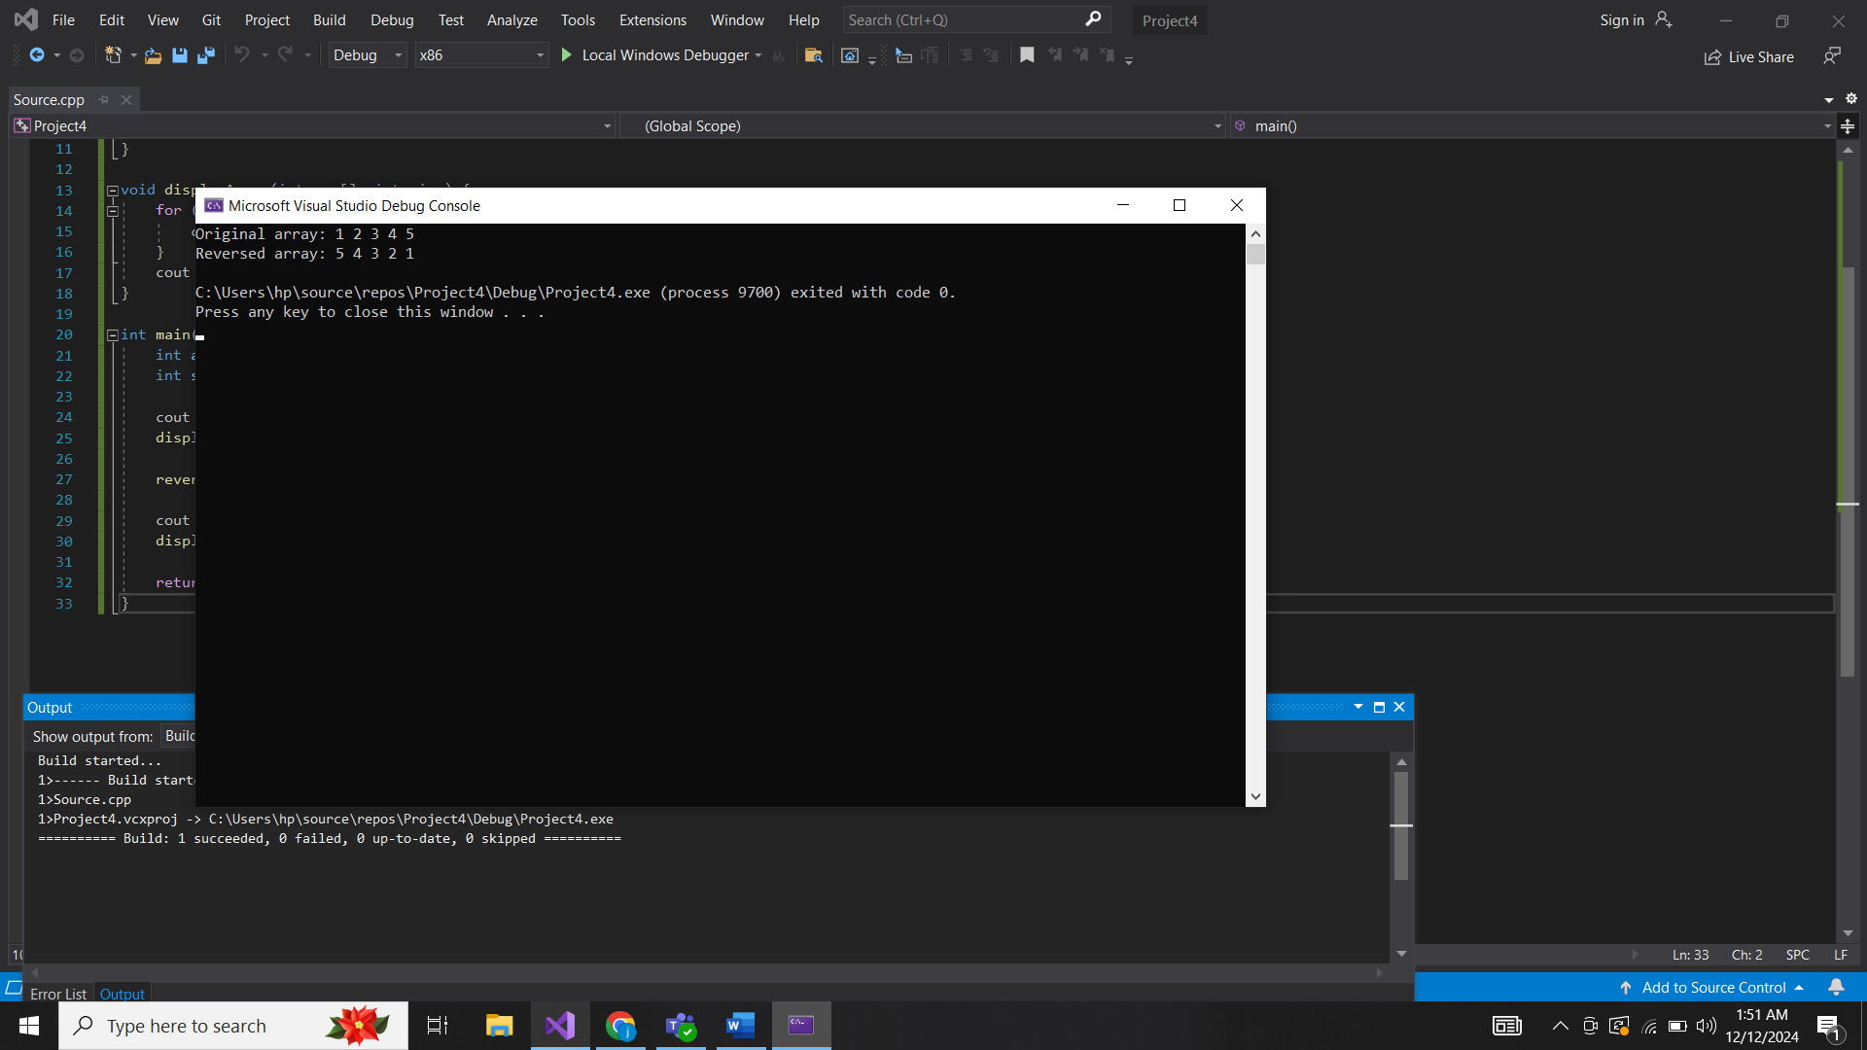

4.

#include <iostream>

using namespace std;

double averageOfElements(int arr[], int size) {

int sum = 0;

for (int i = 0; i < size; i++) {

sum += arr[i];

}

return static_cast<double>(sum) / size;

}

int main() {

int arr[] = { 2, 4, 6, 8, 10 };

int size = sizeof(arr) / sizeof(arr[0]);

cout << "Average of elements: " << averageOfElements(arr, size) << endl;

return 0;

}

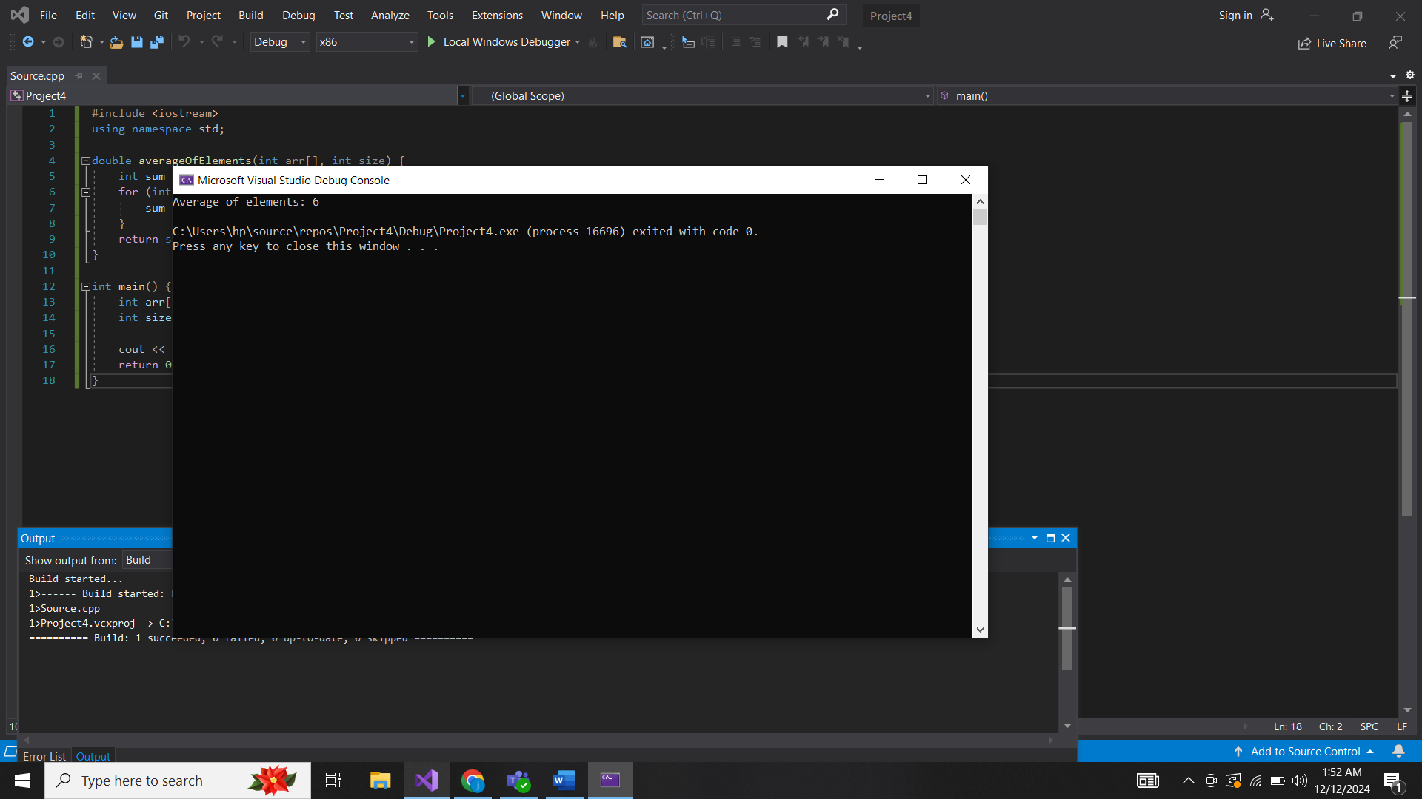

5.

#include <iostream>

using namespace std;

int secondLargestElement(int arr[], int size) {

int largest = arr[0];

int secondLargest = -1;

for (int i = 1; i < size; i++) {

if (arr[i] > largest) {

secondLargest = largest;

largest = arr[i];

}

else if (arr[i] > secondLargest && arr[i] != largest) {

secondLargest = arr[i];

}

}

return secondLargest;

}

int main() {

int arr[] = { 12, 35, 1, 10, 34, 1 };

int size = sizeof(arr) / sizeof(arr[0]);

cout << "Second largest element: " << secondLargestElement(arr, size) << endl;

return 0;

}

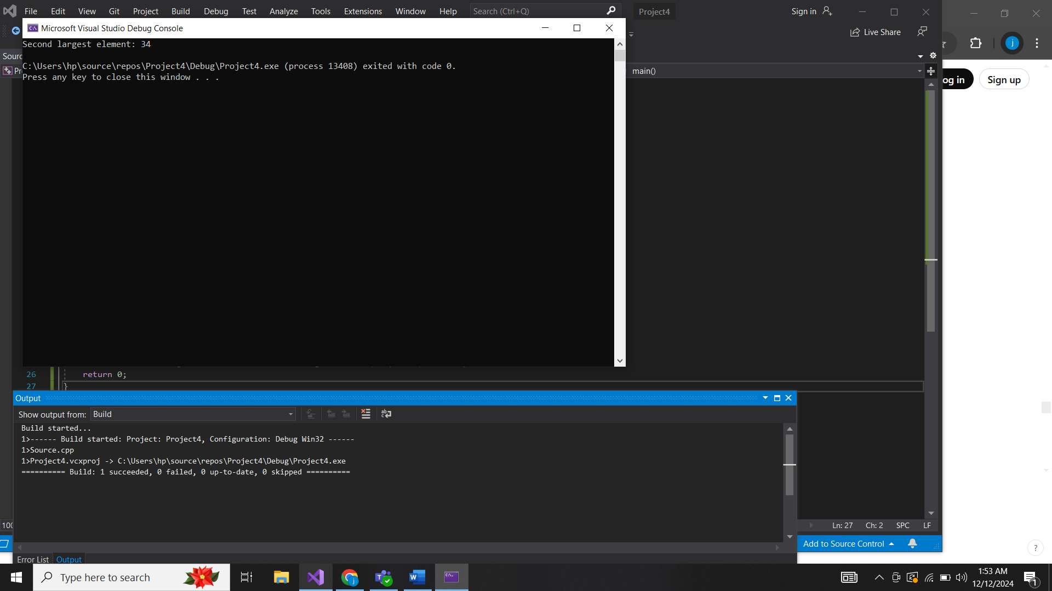

6.

#include <iostream>

#include <algorithm>

using namespace std;

double findMedian(int arr[], int size) {

sort(arr, arr + size);

if (size % 2 == 0) {

return (arr[size / 2 - 1] + arr[size / 2]) / 2.0;

}

else {

return arr[size / 2];

}

}

int main() {

int arr[] = { 1, 2, 3, 4, 5 };

int size = sizeof(arr) / sizeof(arr[0]);

cout << "Median: " << findMedian(arr, size) << endl;

return 0;

}

